Group Worker Interview Pack for candidates

Introduction

Firstly, congratulations on being selected for an interview for the role of Group Worker. This candidate pack has been put together to assist you in preparing for your interview.

The interview itself will take approximately 1 hour and will consist of 4 behaviour based questions and 6 strength based question.

Information on HMP Isle of Wight

A little bit of information on the site you have applied to be a Group Worker at.
- HMP Isle of Wight is a category B prison located within the Long-Term high Security Estate. We are a specialist site that holds People convicted of sexual offences and a small local remand population. The address is: HMP Isle of Wight, 55 Parkhurst road, Newport, Isle of Wight, PO31 5RS
- The programmes team is made up of 15 Group Workers, 3 Prison Officer Specialists, 5 Specialist Treatment Managers and a Programme Manager
- The interventions delivered by the programmes team in HMP Isle of Wight are CSAAP accredited, and are quality assured by HMPPS Interventions Services.

Programmes currently being delivered at this prison.
- Building Choices.
- HSP
- Foundation
Building Choices is a moderate and high intensity offer for men and women age 18+ which is inclusive of people with Learning Disability & Challenges (LDC). The programme supports skill development in emotion management, healthy thinking, healthy relationships, sense of purpose, and healthy sex where relevant.
Further information on these Offender Behavior Programmes can be found here

On the day of the interview

On the day of your interview please park in any of the car parks available. Make your way to the main gate of the Prison and into the Prison. You will be greeted by prison colleagues who will need to check your ID and confirm your identify & will ask who you are here to see. This will be a member of the programmes team.
As you are entering a prison there are certain items which you cannot bring in with you. These items should be left at home or in your car. If you have travelled by public transport speak to the gate staff and they will be able to provide you with a locker.
Here is a list of banned/controlled items although this list is not exhaustive and if unsure you should check directly with the prison: Drugs, explosives, firearms or ammunition and any other offensive weapon, alcohol, mobile telephones, smart watches, cameras, sound recording devices, any tobacco, money, tools, IT equipment including USB sticks, sharp metal objects including cutlery. Only factory sealed liquids are allowed to enter the establishment, we can fill up empty water bottles once through security.
Once you have passed security you will be met by a member of the programmes team, who will have been informed of your arrival. You will be escorted whilst on the premises at all times.

The role of a Group Worker (GW)

We asked some Group Workers already in the role to explain a little about what they do or enjoy about their role.
Each site is different so the views of these Group Workers will vary between Offender Behaviour Programme teams.
“How busy my days are will depend if I’m involved in a programme at that time. If I’m in a group I will deliver that session in the morning then do write ups and prepare for the next day’s session in the afternoon. In between this I am normally completing interviews and assessing men for future groups.”

“I deliver about 5 Building Choices groups a year and for each group I work with 2 other Group Workers, there are always 2 of us in a group room. In each group we usually start with 8 men and work with them for on average 9 weeks.”

“I enjoy the feedback and continuous development. The role takes a strengths based and supportive approach when working with residents. It feels rewarding when residents complete the programme. I think it is important to manage expectations but mostly group members speak of having a positive experience when the programme ends.”

“Each Group Worker has a timetable for the year in my team so we know when the groups we will be facilitating in start and finish. Each programme is different lengths so it means I get to work with different Group Workers throughout the year which is great.”

“I see my role as teaching life skills to men who need them in the aim of reducing their reoffending and regrettable decisions. The thing I enjoy most about the job is getting a group of guys together who don’t know each other and seeing the relationship form between them and how they interact and support each other.”

“This is one of the best roles I have had, It has been fantastic to work with individuals collaboratively, around areas that have significantly affected them and others. To have material that can practically and emotionally support them in navigating the positive steps to improve is so rewarding. I feel proud to be a part of the solution.”

All new Intervention Group Workers are required to complete a series of assessed training courses before they can facilitate Offending Behaviour Programmes (OBPs) in a prison setting. During their first few weeks and months in post, they will receive support to prepare for this training. Courses are booked once they begin the role, and depending on availability, there may be a waiting period of approximately 6–8 weeks.
While awaiting training, new staff will take part in a structured induction and complete a range of assessments. Some training may require travel to external venues; HMPPS will fund all necessary travel and accommodation.
Once fully trained, an Intervention Group Worker will be responsible for assessing and delivering a variety of OBPs, either in group settings or on a one to one basis with individuals who present with a range of offence types.
Offending Behaviour Programmes are CSAAP accredited, psychologically informed interventions. Intervention Group Workers will deliver these programmes alongside Psychology colleagues.

What is facilitating?

Facilitating is very different to teaching or presenting. A Group Worker is a person who helps a group of people to work together better, understand their common objectives, and plan how to achieve these objectives. It will be important to bear this information in mind when delivering your facilitation exercise at your interview.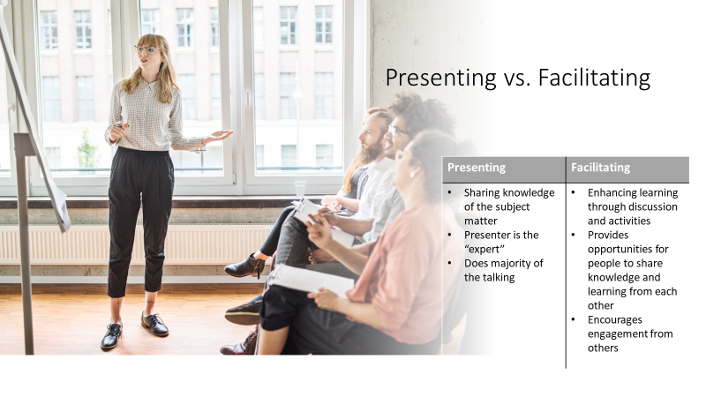

The interview

Your interview will follow the Success Profiles approach. This means you will be assessed across behaviours, strengths, and technical ability, the latter of which includes a short facilitation exercise. Your panel will usually consist of 2–3 members, typically including a Specialist Treatment Manager and a Programme Manager; where a third panel member is present, this role may vary between teams.
The panel’s aim is to give you the opportunity to demonstrate your potential, and they want you to feel able to perform at your best. We hope that the information in this pack helps you feel more prepared and confident.
All interview dates, timings, and joining instructions will be managed through the online recruitment portal you used to submit your application. If you have any questions about the process, please use the contact details provided within the portal or your application correspondence.

Interview Preparation

As part of the interview, you have been asked to complete a facilitation exercise. The role of a Group Worker is detailed above so please use these details to prepare for your facilitation exercise bearing in mind it is not a ‘presentation’.

There are 3 potential topics for your facilitation exercise as follows:

- “Explore the approaches you could take to solve a problem”

- “Explore the potential difficulties of working with group members and how you might manage these”

- “Explore what makes an effective group learning experience”

You will be able to choose one of the topics yourself unless specified by the campaign manager.

To help you prepare for the facilitation exercise, carefully think of the skills that you feel will be needed for the post. Ensure that you structure and plan your facilitation exercise carefully and have any visual aids prepared in advance such as a flipchart or appropriate props. There will be flip chart and pens available on the day to use but you are also able to bring these prepared to the interview.

Please note that PowerPoint will NOT be available for this exercise.

When preparing for your facilitation exercise please consider the following:

- The exercise should last no longer than 10 minutes

- It must be interactive in style i.e. engage the panel in suitable discussions and activities, balanced with demonstrating your knowledge of the topic

- You should ask the panel questions relating to your topic where appropriate

- Ensure that they have understood what you have delivered

A wide variety of information, training and guidance on how to prepare for interviews and the assessments can be found online and are excluded from this guidance. Candidate guidance on Success profile interviewing can be found here: Success Profiles

Top tips from interviewers

- “When preparing for the facilitation exercise bear in mind that the panel are most interested in how you are delivering the exercise, the content is important, but the delivery is key.”
- “We as a panel are more than happy to take part in your exercise, in fact we want to take part so be creative and get us involved”
- “The candidates that stand out are those that can give examples to the questions”
- “When a candidate is answering the behaviour questions it flows so well when they use The STAR method.”
Specific situation
Task
Action
Result of the situation you are describing.
- “When answering the questions try to think of the job role you are interviewing for and the qualities needed for that role, it helps to keep the answers focussed.”

Experiences from previous interview candidates

- “My feedback from the interview was that they really enjoyed how I engaged them in my exercise. I was worried because in interviews before I had done presentations in this interview it felt strange asking them questions to get their contributions, but it did take the pressure off of me because it meant I didn’t have to talk for the whole 10 minutes”
- “The questions were so different to what I had thought, I think I was expecting questions just to be about me and wasn’t prepared for questions such as…what would you do if…?”
- “When I was told in the interview that I would only get 2 minutes to answer a question (strength based questions) I panicked because it didn’t feel long at all, then after I had answered I had so much time left. I wish I had taken my time because 2 minutes is actually a really long time.”
- “Show case your skills in motivating others and be creative in delivery to show you can adapt for different learning styles and responsivity needs. The role is very collaborative, you are always working with a team of Group Workers/treatment managers. The programmes take a collaborative approach to learning when working with residents, so keep this in mind throughout.”

Helpful Links

This publication shows a variety of HMPPS activity in prisons and includes a section about offending behaviour programmes delivery. The tables show the volumes of accredited programmes started and completed in prisons, by programme type, each year. There is a new digest released annually.
HMPPS Annual Digest, April 2020 to March 2021 - GOV.UK (www.gov.uk)
This page will give you a vast overview of success profile interviewing. It will provide you with information on behaviours and strength based questions asked in the interview.
Success Profiles - GOV.UK (www.gov.uk)
You may find the link below helpful to give you an insight into what it is like working for HMPPS and with prisoners in general.
https://prisonjobs.blog.gov.uk/
https://www.gov.uk/guidance/offending-behaviour-programmes-and-interventions

And finally…Good Luck!

