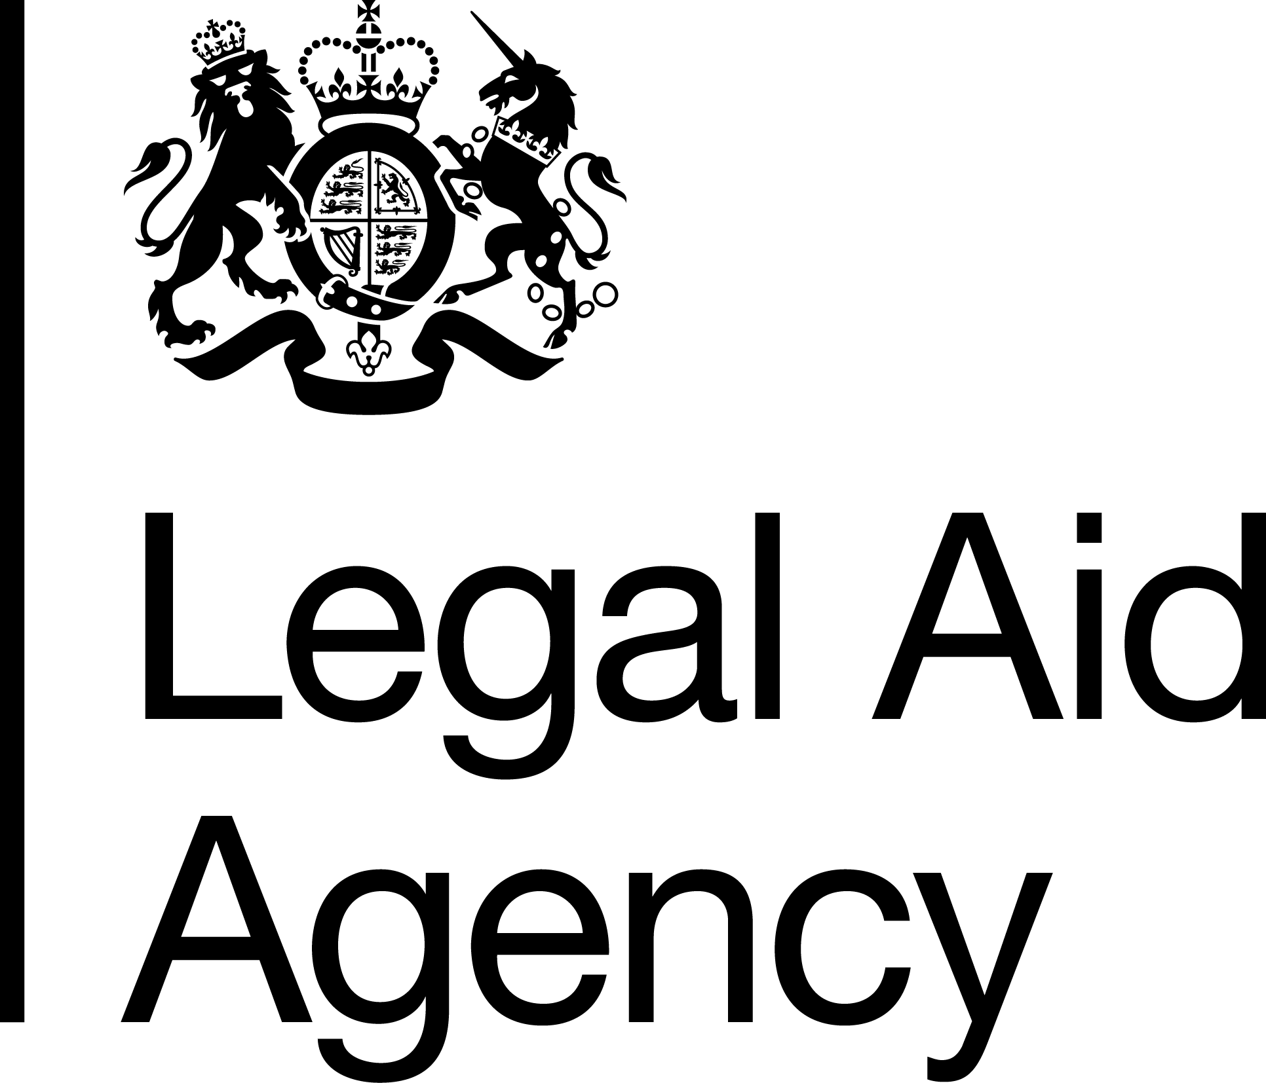

Job Title & Grade: SEO Project Manager
Contract Type: Detached Duty and Loan - 24 months
Salary range (depending on location):
National - £42,914 to £46,182
London - £49,325 to £53,081

Please note that unless you are currently employed by the Civil Service and are earning more than the minimum above, if successful you will be offered the minimum for the grade depending on your location.

Location: National
Please note that whilst this role is open to all Civil Servants, you can only apply for London, Cambridge and Brighton offices if you are a current LAA staff member based in those offices. This is due to and in line with the LAA's Location Strategy and the Cabinet Office's Places for Growth Strategy.

Minimum Working Pattern:

If you are applying for a part time role, please note that to meet business demands we need cover for a minimum of 30 hours over at least 3 days.

To meet legal requirements, if you are between the ages 16-18 and you are a successful candidate, you will be required to complete an apprenticeship after your initial on the job training.

The Legal Aid Agency
We are an executive agency of the Ministry of Justice (MoJ). We are responsible for operationally administering the legal aid fund to provide criminal and civil legal aid advice to people in England and Wales.
Our people are at the heart of achieving excellence. Employing around 1,200 colleagues across England and Wales, we feel proud to have some of the best People Survey results in the Civil Service.

Transformation
Transformation are responsible for continuing to drive forward simplifying the delivery of legal aid. We want to improve the experience for the people who apply for legal aid, the providers who deliver the services and those of us in the LAA who administer the scheme, while ensuring the LAA remains a great place to work.

Transformation Team
This team is leading the transformation of our organisation through innovation, collaboration and inclusion. Originally established in May 2020, the Transformation Team has grown rapidly over the last five years. We are a hybrid team of business change and project delivery experts, and working in partnership with others is at the heart of what we do. We work together with teams across the agency, with the LAA Digital team, MoJ Project Delivery Function experts, MoJ Policy teams and wider stakeholders across the justice system and government.
The transformation portfolio spans multiple services, systems and functions, with significant impacts on:
- Front-line operational teams
- Policy design and implementation
- Digital systems and data
- External providers and partners

Job Summary
The SEO Project Manager will lead the day-to-day delivery of defined projects or workstreams within the Legal Aid Agency’s Transformation Portfolio, with a particular focus on technical and operational change within the Recovery workstream. The role will be accountable for creating structure, maintaining delivery momentum and ensuring activity is planned, controlled and delivered against agreed outcomes.
The Recovery workstream is focused on improving recovery performance, strengthening operational controls, increasing productivity and supporting a more sustainable operating model. This includes coordinating activity to reduce avoidable manual effort and reliance on contingent labour through process improvement, automation opportunities, better use of data and clearer service controls.
You will coordinate and control a complex set of improvement activities across digital, operational, policy, analytical and enabling teams. You will be expected to translate priorities into deliverable plans, manage risks and dependencies, track benefits, support change control and provide clear delivery evidence to inform decisions at workstream and senior governance forums.
This is a technical project delivery role that requires strong organisation, analytical thinking and confident stakeholder management. You will provide visible day-to-day leadership for your workstream, creating clarity in ambiguous situations, influencing across professional boundaries and supporting the transition of improvements into business as usual so that benefits are sustained.

Key Responsibilities:
- Lead the day-to-day planning, coordination and delivery of defined projects or workstreams within the Transformation Portfolio, with a focus on Recovery and related operational improvement activity.
- Establish and maintain robust delivery controls, including project plans, milestone trackers, RAID logs, dependency maps, benefits trackers, change control records, action logs and delivery dashboards.
- Work with operational, digital, analytical and policy colleagues to understand current processes, data, systems and pain points, translating these into clear requirements, delivery plans and implementation activity.
- Drive activity that improves recovery performance, strengthens controls, reduces manual work and supports a more sustainable operating model, including reduced reliance on contingent labour.
- Analyse performance data, management information and delivery evidence to identify trends, inform prioritisation, track benefits and provide clear recommendations to delivery boards and senior stakeholders.
- Influence stakeholders across operations, digital, policy and enabling functions to agree priorities, resolve delivery blockers and maintain momentum against agreed outcomes.
- Manage risks, issues, dependencies, assumptions and change control, escalating with clear options and recommendations where decisions or intervention are required.
- Prepare clear, accurate and evidence-based governance products, including board updates, briefings, commissions, decision logs and assurance material.
- Plan and coordinate implementation, business readiness and transition to business as usual, ensuring operational teams understand impacts, adoption risks, new controls and handover requirements.
- Contribute to continuous improvement across the Recovery workstream by capturing lessons learned, improving delivery tools and role-modelling consistent project management standards.
- Build constructive and inclusive relationships with colleagues and stakeholders, creating space for different perspectives and ensuring communication is accessible and respectful.
- Promote inclusive delivery practices by considering user, colleague and provider impacts when planning, implementing and embedding change.

Essential Knowledge, Experience and skills
- Experience of managing projects, workstreams, operational improvement or transformation activity in a complex organisation.
- Experience of applying project delivery controls, including plans, milestones, RAID, dependencies, governance reporting, change control and benefits tracking.
- Ability to use data, management information and delivery evidence to support prioritisation, recommendations, performance conversations and benefits realisation.
- Experience of working with digital, operational, analytical, policy or enabling teams to shape requirements, coordinate delivery and implement change.
- Ability to communicate and influence effectively with a range of stakeholders, including translating complex or technical information into clear advice for senior audiences.
- Experience of supporting implementation, business readiness and transition to sustainable ways of working, while promoting inclusive collaboration across teams and stakeholder groups.
Desirable Knowledge, Experience and skills
- Experience of working in a project delivery, portfolio, programme management office, transformation or operational recovery environment.
- Experience of supporting digital change, automation, service improvement, process redesign or operating model change.
- Experience of working with delivery tools and artefacts such as Jira, Planner, RAID logs, delivery dashboards, benefits trackers, process maps or requirements documentation.
- Experience of supporting activity that improves productivity, reduces manual work, strengthens controls or reduces reliance on temporary or contingent resource.
- Experience of supporting governance forums, preparing board papers, coordinating commissions or contributing to senior-level reporting.
- A project delivery qualification or comparable professional training, accreditation or practical experience, such as Agile, PRINCE2, APM, Lean, Prosci or continuous improvement methods.
- Knowledge of the Legal Aid Agency, including its operational context, services, stakeholders and the wider justice environment in which it operates.
Person Specification
We are looking for people who are organised, analytical and confident working in a technical or operational delivery environment. You will be able to bring structure to complex work, understand detail quickly and help teams turn improvement ideas into practical delivery plans.
You will be comfortable working with project controls, data, risks, dependencies and delivery evidence. You will be able to identify what needs attention, ask constructive questions and support colleagues to make informed decisions. You do not need to be a technical specialist, but you should be confident working with technical colleagues and translating complex information into clear, practical updates.
You will be collaborative, inclusive and able to build trust with people across different professions and levels of seniority. You will listen to different perspectives, communicate clearly and help create an environment where people feel able to contribute.
You will be motivated by improving public services and supporting change that delivers measurable benefits for users, providers and colleagues. You will be proactive, adaptable and willing to learn, with the judgement to know when to take action, when to escalate and when to seek advice.

Assessment approach
Application Process – Statement of Suitability
To apply, please provide a statement of suitability showing how you meet the essential criteria in no more than 1,000 words.

Your statement should demonstrate your ability to meet all of the essential criteria listed. Using examples can help strengthen your application. You may wish to include examples that show how you have planned, coordinated or delivered technical, operational or transformation activity; managed risks, issues, dependencies, milestones or project controls; worked with data, management information or delivery evidence to support decisions; supported digital change, automation, service improvement or process redesign; contributed to work that improves productivity, reduces manual effort or supports a more sustainable operating model, including reducing reliance on contingent labour; communicated complex information clearly for different audiences, including senior stakeholders; and supported inclusive ways of working across teams, professions or stakeholder groups.

Please note we do not require a CV.

Please note that we only require a Statement of Suitability for your application. The wording on this advert may suggest that an Experience question is also required, however this is not necessary.

Interview / assessment Process

If you are successful through the application stage, you will be invited to an interview / assessment centre in person or via Microsoft Teams where you will be assessed against the following:

Strengths relevant to the role and the following Behaviours:
- Delivering at Pace
- Working Together
- Communicating and Influencing
- Changing and Improving

Your Experience of implementing, promoting, or understanding diversity and inclusion policy - Diversity is the presence of difference, this can include one or more of the protected characteristics (Gender, Age, Race, Disability etc.) or it can be about working patterns, whether we like to jump into a task or reflect on it before acting. Inclusion is how we welcome, value, and celebrate diversity, giving everyone a voice, tapping into ideas, and enabling everyone to be themselves at work and achieve their potential.

For this grade/role we would expect candidates to demonstrate understanding of Diversity and Inclusion and explain why they are important in a work environment. We would also expect examples of action they have taken to embrace diversity, such as increasing understanding for themselves or others, or improving inclusion at a team or wider group level.

Shortlisting is planned for week commencing 14th September 2026
Interviews are planned for week commencing 24th September 2026
If you would like more information on this opportunity, please contact – Ieuan Jones at Ieuan.Jones@justice.gov.uk

Our LAA commitment to Diversity and Inclusion
The Civil Service is committed to attract, retain, and invest in talent wherever it is found. To learn more please see the Civil Service People Plan and the Civil Service Diversity and Inclusion Strategy.
As a Disability Confident organisation, we will offer a guaranteed interview to candidates with a disability who meet the essential criteria for this role. Under the Equality Act 2010 a disability is defined as a physical or mental impairment which has a substantial and long-term adverse effect on your ability to carry out normal day-to-day activities which has lasted, or is expected to last, at least 12 months.
If you are responding to a role within the Legal Aid Agency and would like to be considered under the guaranteed interview, please indicate this in your application and let us know of any reasonable adjustments you may require during the sift or later selection processes.
The LAA’s goal is to build an organisation that is open and inclusive and truly values and celebrates the diversity of its workforce. One that reflects and understands the needs of the diverse society we serve. This is regardless of social background, gender, age, ethnicity, sexual orientation, beliefs, disabilities or long-term illness or caring responsibilities.
Reasonable Adjustments
We are committed to ensuring our recruitment process is inclusive and accessible to all. If you have a disability or long-term condition (for example dyslexia, anxiety, autism, a mobility condition or hearing loss) and need us to make any reasonable adjustments to support you through the recruitment process, please let us know by adding the information to the applications system or emailing LAARecruitment@justice.gov.uk after you have applied so that we can discuss options with you.


Complaints procedure
If you have any complaints about this recruitment activity, please share your concerns by emailing LAARecruitment@justice.gov.uk initially. We aim to respond to any complaint within 10 working days.

