Performance Deputy Director
Planning, Performance and Risk Directorate, Ministry of Justice HQ
SCS Pay Band 1
Closing Date: 23:55 Sunday 23rd August 2026

About the Ministry of Justice
The Ministry of Justice is at the centre of the justice system, with responsibility for services that are fundamental to public confidence, the rule of law and the effective functioning of society. We lead work that protects the public, supports victims, safeguards rights and enables individuals, families, communities and businesses to access justice fairly and efficiently.

As a major ministerial department, the Ministry of Justice works to protect and advance the principles of justice. Our ambition is to deliver a modern, high-performing justice system that commands confidence, responds to changing demands and works for everyone in society.
The department’s work has profound national significance. It helps keep people safe, underpins fairness and due process, protects individual rights and supports the confidence on which economic activity and social stability depend. Across this broad and complex portfolio, our priorities focus on delivering better outcomes for the public through three core strategic aims:
- Protecting the public and reducing reoffending by strengthening prison, probation and youth justice services so that punishment is effective, rehabilitation is credible and communities are safer.
- Delivering swifter and more effective justice for victims and court users through modern, efficient and resilient courts and tribunals services.
- Upholding the rule of law and sustaining a justice system that is accessible, fair and outward-looking, while supporting world-leading legal services and wider economic growth.
For further information about the Ministry of Justice and the breadth of its work, please visit: Ministry of Justice
Welcome to Planning, Performance and Risk Directorate (PPRD)

Thank you for your interest in this opportunity with the Planning, Performance and Risk Directorate.



This is an exciting opportunity to take on a pivotal leadership role at the heart of the Ministry of Justice within the Chief Operating Officer Group. This role will be fundamental in enabling the MoJ to improve performance in priority areas and help shape a culture that delivers the Permanent Secretary’s priorities. As the department goes through a period of change, the postholder’s expertise will be central to shaping how the department delivers better services for the public.
The Planning, Performance and Risk Directorate translates the Ministry of Justice's ambition into delivery. We define the priorities, outcomes, and measures of success for the organisation, and provide the strategic grip, insight, and assurance needed to drive performance, manage risk, and respond to emerging challenges.
We are looking for leaders who combine judgement, credibility and purpose with the ability to deliver meaningful impact in complex environments. This is an opportunity to take on work of real consequence, influence strategic direction and help shape outcomes that matter to the public.
At the Ministry of Justice, senior leaders operate in a context that is demanding, high profile and deeply purposeful. You will join an organisation that values inclusive leadership, intellectual curiosity, collaboration and a strong commitment to public service.
We hope this pack gives you a clear sense of the scale of the opportunity, the expectations of the role and the experience of working here. If your values, leadership style and ambitions align with what you read, we would be delighted to receive your application.
Best wishes,
Raj Johal
Director, Planning Performance and Risk
The Role

Job Title
Deputy Director Performance
Location
National
All successful candidates will be appointed to the nearest viable office nearest to their home postcode. This will be at either an HQ building (subject to desk allocation), a JCC or JSO - See Map .

All employees will be expected to spend a minimum of 60% of their working time in an office, (subject to local estate capacity). The MoJ is working to open more Justice Collaboration Centres and Justice Satellite Offices over time.

Please review the FAQs for further information on travel expectations and the level of flexibility associated with the role.

Salary
The salary for this role falls within the MoJ SCS Pay Band 1 range (£86,000 to £117,800).

For external candidates, the starting salary on appointment is expected to be £86,000 per annum.

Existing Civil Servants will be appointed on level transfer or promotion in line with Civil Service pay arrangements. On promotion, salary will increase either to the minimum of the SCS Pay Band 1 range or by up to 10% of current basic salary, excluding allowances, whichever is greater.
Candidates appointed on level transfer will retain their existing basic salary, excluding allowances.
Contract Type
This role is offered on a permanent basis.

This role has an expected minimum assignment duration of three years, reflecting the deliverables identified. This is an expectation rather than a contractual requirement and does not form part of your terms and conditions.

If applying as job share partners, please review the guidance here; hub page | Civil Service Careers (civil-service-careers.gov.uk)

The Role
The Deputy Director of Performance is a new role that will report directly to the Director of Planning, Performance & Risk. This is a rare opportunity to shape how one of Whitehall’s largest departments understands, challenges and improves performance across a complex justice system.

The Permanent Secretary has set a clear ambition – a step-change in how we manage performance to achieve better outcomes through greater transparency, stronger reporting and increased consistency. The department is committed to building a high-performance culture – setting high standards, supporting and challenging each other, and using innovation to raise our game. The role will also ensure the effective delivery of the Lord Chancellor’s priorities by leading and monitoring accurate and informative Key Performance Indicators (KPIs).

This is a high profile, critical area of work, which will face significant internal and external scrutiny, up to and including ministerial level.

The role requires a confident individual who will maintain strategic relationships across five executive agencies, four HQ groups and Arm's Length Bodies (ALBs).

Working across boundaries, the postholder will build strong and trusted relationships with stakeholders at all levels, ensuring a good level of understanding of the department’s strategy and its system wide outcomes.

The post holder will lead a team of approximately 15–20 people and work as part of a Directorate Leadership Team comprising five other Deputy Directors.

Key Responsibilities
Reporting into the Director of PPRD you will:
- Establish, lead and motivate a high-performing, diverse, inclusive and multidisciplinary team, setting a clear vision, purpose and operating model that strengthens delivery grip across MoJ.
- Conduct high-quality deep dives and evidence- based performance assessments on the department’s highest priority areas, identifying emerging risks, dependencies and good practice.
- Ensure performance data and insight are timely, to a high standard and used effectively to drive decision-making in forums including the Justice Performance Board, Departmental Board, Executive Committee and regular ministerial discussions.
- Effect positive changes to the way we work, delivering a combination of rapid and long-term projects focussed on a limited number of specific priorities, working with the department to drive improvements, linking outcomes, priorities, metrics and delivery plans.
- Use quantitative and qualitative insights to develop delivery improvement hypotheses, working constructively with senior leaders to understand, support and challenge areas that require improvement.
- Develop and maintain close working relationships within the department, across government and with key external stakeholders, using collaboration and diversity of thought to better enable the department to understand how it can improve performance priority areas.
- Drive effective governance, performance reporting and assurance across the department and wider justice system, ensuring clear oversight of delivery, identifying risks and dependencies, and providing constructive support and challenge to enable successful outcomes.
- Provide strong leadership, influence and direction; act as a trusted adviser to Ministerial and Executive teams on delivery challenges and performance improvement, building strong relationships with leaders across the justice system to track performance and guide action.
- Promote a culture of continuous improvement, curiosity and constructive challenge by building in a performance routine and a cycle of learning to facilitate high-quality decision-making.

Additional Responsibilities
- Form part of the leadership team of the department, supporting the Director to meet all corporate responsibilities.
- The shape of the Directorate is changing and, as a result, the post holder's role and responsibilities may evolve over time to meet emerging business needs and priorities.

Person Specification

Throughout the selection process, you should provide clear evidence and examples that demonstrate how you meet the essential and desirable criteria for the role.
Later in this pack, you will find details of which elements will be assessed at each stage of the process, helping you focus your application and prepare effectively.



Essential Experience:
- Proven experience of using evidence, data and analysis to drive performance in a complex operational/delivery environment.
- Proven experience of working at pace, shaping effective and timely decisions through strong data literacy, data storytelling and data intelligence with the ability to interpret performance data, exercise sound judgement, and distil complex insight into clear messages.
- An excellent team player with the ability to work collaboratively across the department, build trust and establish credibility with a range of stakeholders to solve complex and systemic problems even when needing to deliver difficult messages or challenge established ways of working.
- Ability to build credibility and trust quickly in order to influence across organisational boundaries including with senior leaders, Ministers and Permanent-Secretaries or equivalent.
- Experience of building and leading high-performing, inclusive, multi-disciplinary teams and leading through change with a commitment to developing capability and talent.
- Strong strategic judgment, sound problem-solving skills with the ability to anticipate future trends, provide deep insight and identify ways to address challenges and support business outcomes.
Desirable Experience:
- Experience of working in or with operational delivery organisations, particularly in the justice system.
- Experience of developing or operating strong systems of performance reporting and governance.
- Understanding of cross-government planning, performance, delivery and assurance frameworks.

MoJ SCS Pay Band 1 Behaviours:
You will also be assessed against the following Behaviours during the Recruitment Process:
- Changing and Improving
- Making Effective Decisions
- Leadership
- Seeing the Big Picture

The Recruitment Process

Support during the selection process
If you need support or would like to discuss any aspect of the process, please contact the SCS Recruitment Team at scsrecruitment@justice.gov.uk. We are here to help candidates engage with the process confidently and fairly.
Stages of the selection process
You are invited to arrange an informal conversation with Raj Johal to learn more about the opportunity and the organisation before submitting an application. This conversation is separate from the assessed process and is intended to help you make an informed decision about applying.
Application
Applications must be submitted online via the link in the advertisement for this role.
Applications must be received by 23:55 on 23rd August 2026. As part of your application, you will be asked to provide:
Eligibility responses confirming that you meet the requirements to apply.
An indication of whether you wish to request reasonable adjustments during the selection process. The Disability Support section explains the support available.
- 10
- Please note that if you do not submit both a CV and a Supporting Statement, the panel may have insufficient evidence on which to assess your application against the person specification.
Find out more information and guidance on our application process here.
After the Application Stage
You will be informed whether your application has been shortlisted for the next stage. If shortlisted, we will contact you with full details of the next part of the process and any preparation required.
Due to the anticipated volume of applications, we are unable to provide feedback to candidates who are not shortlisted. Candidates who are shortlisted and attend interview will be offered verbal feedback from a member of the panel.
Assessments
Panel Interview and Presentation
You will be invited to attend an interview and presentation with the selection panel. You will be asked to prepare a verbal 5-minute presentation based on a topic that will be provided in advance. The interview and presentation will last approximately 45 minutes.
What is being assessed?
Behaviours, as listed on page 12.
After the Panel Interview
Following the interview stage, the panel will consider all evidence and identify the appointable candidate. Candidates will be notified of the outcome as soon as possible after interviews conclude. If you are not appointed but meet the required standard, you may be invited to have your details retained on a merit list for future SCS opportunities.

Guidance for Writing your Statement and CV

As part of your application, you will be asked to submit a CV and Statement of Suitability. Together, these should provide clear evidence that you meet the essential criteria set out in the Person Specification.
Read the role information carefully and address each essential criterion with relevant evidence. Focus on your most significant and recent achievements, making clear the context, scale of your contribution and the impact you delivered.
When preparing your Statement of Suitability, it may help to:
- Present your evidence clearly so the panel can see how your experience aligns to the essential criteria.
- Use recent, relevant examples that show the scale of your responsibilities, the complexity you handled and the outcomes you achieved.

Using AI in your application
Artificial Intelligence may help you shape or refine your application, but everything you submit must be accurate, authentic and based on your own experience. Examples should reflect your personal contribution and judgement. Applications may be withdrawn where content is misleading, plagiarised or not the candidate’s own work. Internal candidates may also be subject to disciplinary action.

Please see our candidate guidance for more information on appropriate and inappropriate use.
Providing a name-blind CV and Success Profile Statements
Please ensure your CV and Statement of Suitability are name-blind. Remove personal information that is not relevant to the assessment of your suitability for the role, for
example;

- Name and title
- Educational institution names
- Age and gender
- Email address
- Postal address and telephone number
- Nationality and immigration status.

This supports a fair and objective assessment by enabling the panel to focus on your evidence, capability and potential rather than personal identifiers.

For more information and guidance on how to write your Statement and CV please visit the Senior Civil Service web page.

Civil Service Behaviours

What are Behaviours?
The Civil Service recruits using Success Profiles. Behaviours are one element of that framework and help assess how candidates demonstrate the leadership qualities, judgement and ways of working needed to succeed in the role.
For this campaign, the behaviours most relevant to the role will be assessed during the interview stage of the process. The descriptions below are included to help you understand what each behaviour looks like in practice.
Changing and Improving
You create an environment of continuous improvement and change. You see the benefit of change and promote this within your area of responsibility. You identify business needs, both current and future, and use this to identify opportunities for change, utilising innovative solutions that benefit the end user. You are able to embed change, managing risks. You evaluate the impact of change against the expected outcomes for service users and the public.
Making Effective Decisions
You make defensible, objective and fair high-impact decisions, considering the impact on the service user and wider organisation. You are willing to take ownership of your decisions, being transparent and open about the reasons for them. You effectively analyse data to make evidence-based decisions, whilst being comfortable taking considered risks based on the best evidence available. You consult with others to incorporate views and professional expertise, ensuring appropriate individuals are involved in the decision-making process.
Leadership
You visibly demonstrate the organisation’s values in all your activity, leading authentically. You seek to engage staff in the aims of the organisation and communicate the organisation’s strategy in an inspiring way. You create an inclusive and fair culture which creates a sense of belonging by treating staff as individuals and actively valuing diversity within the organisation. You empower teams and individuals to excel by creating a shared vision and objectives and demonstrate trust in staff by giving autonomy.
Seeing the Big Picture
You understand the wider context of the organisation’s work, considering the political, social, economic, and technological environment both currently and in the future. You create and implement strategies to achieve the organisation’s aims and meet the needs of the public. You promote the organisation externally, advocating positive outcomes for the sector you operate within. You motivate staff by ensuring they understand how their work fits into the big picture.
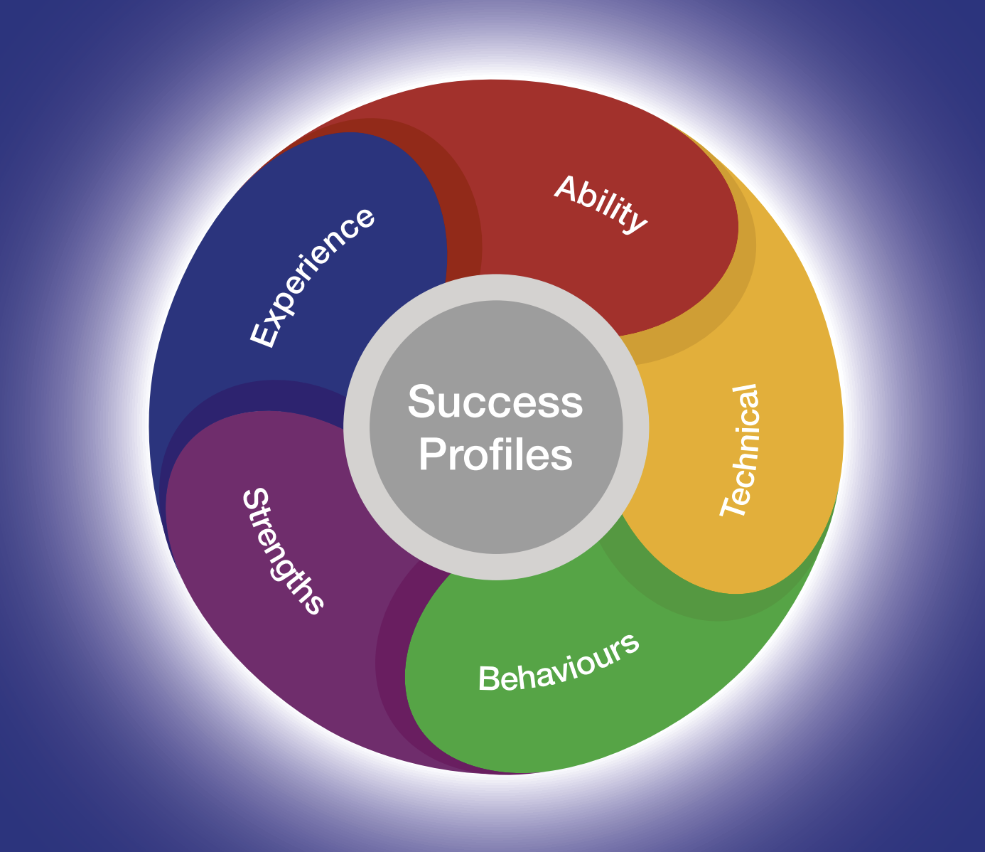
For further guidance on Behaviours and Success Profiles, please visit our Senior Civil Service web page.

Expected Timeline

We will aim to offer as much flexibility as possible; however, it may not always be feasible to provide alternative dates for assessments or interviews. We therefore encourage candidates to review the timetable carefully and keep the relevant dates available where possible. Please note that the timetable may be subject to change.

The anticipated timetable is as follows:
Advert Closing Date | 23:55 Sunday 23rd August 2026
Outcome of CV and Statement of Suitability | Week commencing 31st August 2026
Panel Interview and Presentation | Week commencing 7th September 2026

Working at the Ministry of Justice


The Civil Service Code
The Civil Service Code sets out the values and standards expected of all civil servants. Issued by the Prime Minister as Minister for the Civil Service, it is founded on four core principles—integrity, honesty, objectivity and impartiality—and forms part of the contractual relationship between civil servants and their employer.

Equality, Diversity, Inclusion and Wellbeing
The Ministry of Justice offers senior leaders the opportunity to lead work of national importance in an organisation defined by public purpose, integrity and visible impact. Our values—purpose, humanity, openness and together—shape a culture of pace, integrity and inclusive leadership. We are committed to a diverse, high-performing workplace that reflects the society we serve, where different perspectives, wellbeing, belonging and sustainable leadership matter.
Benefits
As part of the Ministry of Justice, you will benefit from a competitive package that supports your wellbeing, flexibility and longer-term career development, including:
Pension
You will have access to the alpha pension scheme, which includes a 28.97% employer contribution and comparatively low member contributions by public sector standards.
The Civil Service Pension Scheme is a significant part of the overall reward package, offering long-term security and valuable benefits for you and your family. Further details are available at www.civilservicepensionscheme.org.uk.
Generous Annual Leave and Bank Holiday Allowance
You will receive 25 days’ annual leave on entry, rising to 30 days after five years’ service, in addition to 8 public holidays and a day of paid privilege leave to mark the King’s Birthday.
Flexible Working
We support flexible and hybrid working where this aligns with the needs of the role and the business, helping leaders balance impact, collaboration and personal wellbeing.
Further information on benefits, including pension, leave and Equality, Diversity, Inclusion and Wellbeing support, is available on our Senior Civil Service web page.

Disability Support

Do you offer a Disability Confident Scheme for Disabled Persons?
As a Disability Confident employer, the Ministry of Justice is committed to creating a recruitment process that is fair, accessible and inclusive. In most campaigns, disabled candidates who meet the minimum selection criteria will be offered an interview. You will be able to indicate on the application form whether you would like to be considered under this scheme.
What reasonable adjustments can be made if I have a disability?
We want every candidate to be able to take part in the selection process on a fair and equitable basis. For senior roles, that means giving you the opportunity to demonstrate your experience, judgement and leadership capability fully, with reasonable adjustments in place where needed.
If you would like to request support or discuss an adjustment in confidence, please indicate this on your application form by selecting ‘yes’ to reasonable adjustments and responding to the Reasonable Adjustments Scheme team by email. We encourage you to raise any requirements as early as possible so that arrangements can be put in place in good time.
How we can support you
A range of reasonable adjustments can be considered across the selection process, depending on your circumstances and the nature of the assessment. Our aim is to work with you to identify support that enables you to take part with confidence and on an equal footing.

Examples may include:
- Extra time to complete assessments.
- Providing a break within an assessment.
- Providing interview questions in a written format at the interview as well as orally.
- An interview at a certain time of day.

These examples are illustrative rather than exhaustive. Appropriate support will depend on your individual circumstances, and each request will be considered thoughtfully and on its own merits.

We will make every reasonable effort to provide the adjustments requested. Where a particular adjustment is not possible, we will explain this clearly and work with you to explore appropriate alternatives wherever we can.
Help with your application
If you think you may need an adjustment, we encourage you to contact us as early as possible so arrangements can be made with sufficient notice and support can be tailored to your needs.
If your circumstances change during the process, or you identify a need for support after applying, please contact the SCS Recruitment team in advance of your next assessment wherever possible.
If you have any questions before applying about reasonable adjustments, please contact the SCS Recruitment team at scsrecruitment@justice.gov.uk. We will be happy to help.

Diversity and Inclusion

At the Ministry of Justice, we believe inclusive, respectful and high-performing workplaces are essential to delivering better outcomes for the public.
We want talented people from every background to feel welcomed, valued and able to succeed here.
That commitment shapes how we recruit, develop and support our people—and helps create an environment where diverse perspectives strengthen leadership, decision-making and impact.


We know the strongest leadership teams reflect the diversity of the society they serve. That is why we are committed to building an inclusive Civil Service where talented people from all backgrounds can thrive, contribute and lead with confidence.
Our Diversity and Inclusion Strategy focuses on creating a Civil Service that:
- draws on the broadest possible range of talent, experience and perspective
- is visible, accessible and open to people from all backgrounds
- supports flexible, inclusive ways of working that help people and performance flourish
- attracts, develops and retains exceptional leaders at every stage of their career

For executive candidates, this means joining an organisation that values inclusive leadership, sees difference as a strength, and is committed to creating the conditions for diverse talent to succeed, influence and shape outcomes of national importance.

FAQs

Can I apply if I am not currently a civil servant?
Yes. This role is open to both internal and external applicants.
Is this role suitable for part-time working?
This role is offered on a full-time basis. Flexible working options, including job share, may be considered where they align with business need.
Where will the role be based?
If appointed, your base location will be National.

Please note that relocation expenses will not be payable.
The role will require travel predominantly to London, but some cross-country travel will also be required.
Can I claim back any expenses incurred during the recruitment process?
Expenses incurred during the recruitment process will not usually be reimbursed, except in exceptional circumstances.
Am I eligible to apply for this role?
For further guidance on eligibility to apply for this role, please refer to GOV.UK.
Is security clearance required?
Yes. If successful, you will be required to obtain security clearance to SC level, if you do not already hold it. Further information about the vetting process can be found here.
Will this role be overseen by the Civil Service Commission?
No. However, this recruitment campaign will be conducted in accordance with the Civil Service Commission’s Recruitment Principles.
What do I do if I want to make a complaint?
All appointments to the Civil Service must be made on merit, on the basis of fair and open competition, and in line with the Civil Service Commission’s Recruitment Principles.
If you believe these principles have not been followed and wish to make a complaint, you should first contact scsrecruitment@justice.gov.uk.
If you are not satisfied with the response, you may escalate your complaint in the following order:
- Shared Services Connected Ltd (0845 241 5358, Monday to Friday, 08:00 to 18:00, or (Moj-recruitment-vetting-enquiries@gov.sscl.com)
- Ministry of Justice Resourcing (resourcing-services@justice.gov.uk)
- Civil Service Commission (civilservicecommission.independent.gov.uk/contact-us)
What should I do if I think that I have a conflict of interest?
If you believe you may have a conflict of interest, you must declare this before submitting your application by contacting the SCS Recruitment team at scsrecruitment@justice.gov.uk.

Data Sharing

We will handle your personal information with care and in line with applicable data protection law, including the UK General Data Protection Regulation and the Data Protection Act 2018.

Data Sharing
To administer your application, your personal data will be shared only with the Ministry of Justice SCS Recruitment Team, panel members and others directly involved in the recruitment process where necessary.
The legal basis for processing your personal data is:
- Processing is necessary for the performance of a task carried out in the public interest. In practice, this supports the fair and effective administration of recruitment and helps the Civil Service improve candidate and employee experience.
- Sensitive personal data includes information such as racial or ethnic origin, religious beliefs, trade union membership, health data and other special category data protected by law.
- Processing may be necessary for reasons of substantial public interest, including the exercise of functions by the Crown, a Minister of the Crown or a government department, and to understand whether different groups experience the Civil Service differently so that appropriate action can be taken.
- Processing may also be necessary to identify or review equality of opportunity and treatment between groups, with a view to promoting or maintaining that equality.
- If you are successful, relevant sensitive personal data will also be used during onboarding to create your employee record.
- For further information please see the GDPR Privacy Notice.

Contact Us

Should candidates wish to discuss the role in more detail before submitting an application, please contact SCS Recruitment on scsrecruitment@justice.gov.uk.

