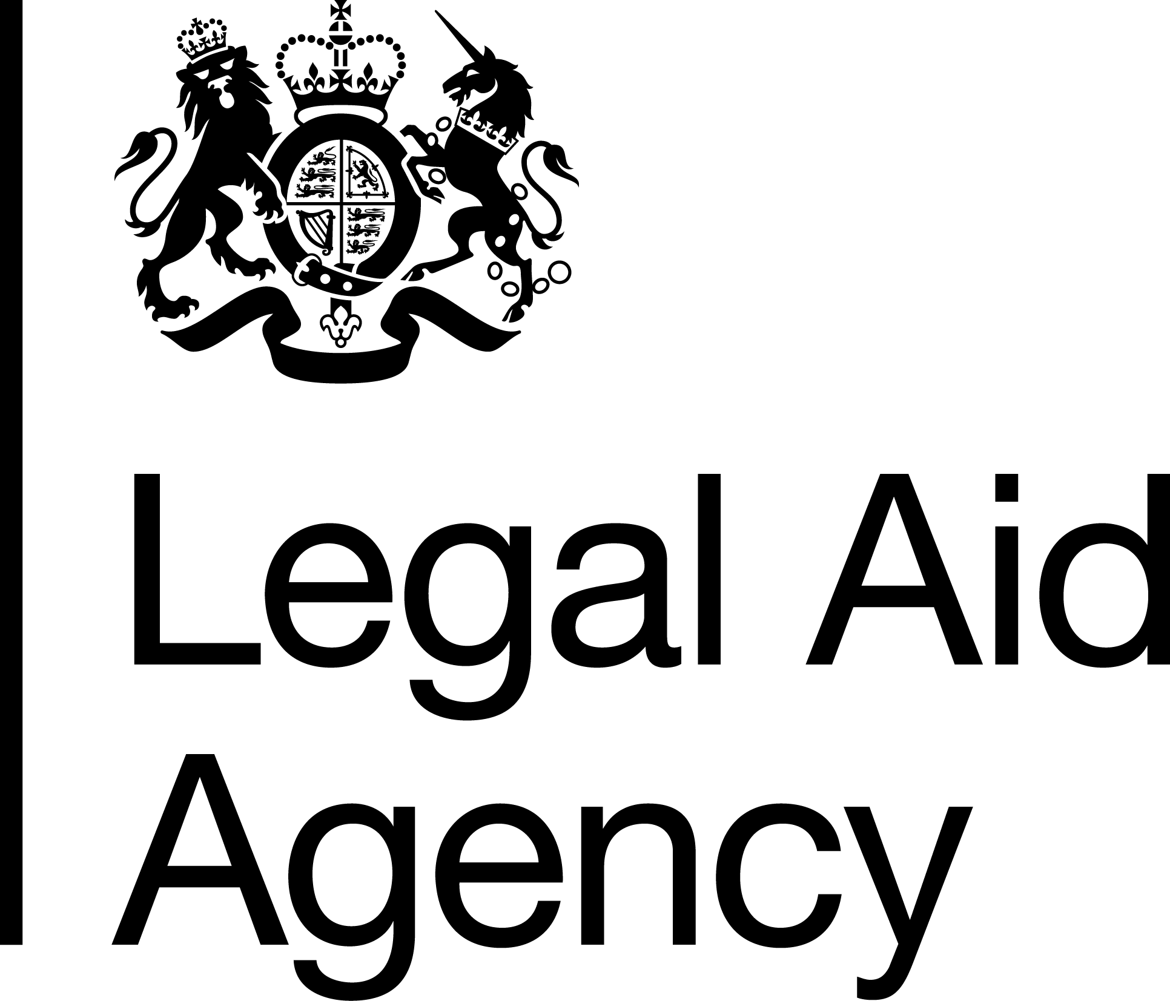

Job Title & Grade: Senior Information Assurance Officer - SEO
Contract Type: Permanent
Salary range (depending on location):
National - £42,914 - £46,182
London - £49,325 - £53,081

Please note that unless you are currently employed by the Civil Service and are earning more than the minimum above, if successful you will be offered the minimum for the grade depending on your location.

Location: Any LAA office.
Please note that whilst this role is open to all, you can only apply for London, Cambridge and Brighton offices if you are a current LAA staff member based in those offices. This is due to and in line with the LAA's Location Strategy and the Cabinet Office's Places for Growth Strategy.
40% office attendance is required. That may be at your base location and other offices. Occasional travel to other offices will be required.

Minimum Working Pattern:

If you are applying for a part time role, please note that in order to meet business demands we need cover for a minimum of 21 hours and to cover 3 days of the week.
To meet legal requirements, if you are between the ages 16-18 and you are a successful candidate, you will be required to complete an apprenticeship after your initial on the job training.

The Legal Aid Agency
We are an executive agency of the Ministry of Justice (MoJ). We are responsible for operationally administering the legal aid fund to provide criminal and civil legal aid advice to people in England and Wales.
Our people are at the heart of achieving excellence. Employing around 1,200 colleagues across England and Wales, we feel proud to have some of the best People Survey results in the Civil Service.

Assurance Directorate
LAA’s Assurance teams ensure effective governance of the agency through our executive committees and deliver the practices, procedures and processes to provide our Chief Executive with assurance that LAA is appropriately managing risks relating to fraud, error in decision making, financial stewardship, health and safety, information security, data protection and business continuity.

Corporate Assurance, Risk and Secretariat
The CARS team combines the 5 functions of Health & Safety, Information Assurance & Security, Business Continuity, Risk and Secretariat to collectively strengthen and support the LAA’s governance, our assurance strategies, risk management processes and provide support to the LAA’s senior governance forums including the Board and Executive Leadership Team.
This role sits within Information Assurance & Security, a function that ensures the LAA appropriately protects and manages a significant volume of often very sensitive data relating to legal aid clients, our staff, legal aid Providers and other third parties. Our work ensures the LAA meets its obligations under Data Protection legislation and UK Government security standards.

Job Summary
You will play a key role in ensuring that projects and initiatives across the LAA, primarily involving new or modernised IT systems, are delivered in a manner that ensures government security standards and data protection requirements are met to ensure that sensitive data is protected. You will provide advice and support to project teams on information security and data protection requirements and work closely with stakeholders to deliver Secure by Design solutions. You will take a leading role in the management of information risk and provide assurance to senior leaders.
As part of the Information Assurance & Security team you will work with staff at all grades across the organisation to build and improve LAA’s security culture, deliver training and respond to security incidents.
Key Responsibilities:
- Provision of expert advice and support to stakeholders across the LAA on the application of Data Protection Legislation, Secure by Design principles and information risk management in their business area.
- Provision of risk assessments and controls and providing advice on information security risk, including to senior leadership
- Close working with other security stakeholders across MoJ to manage security risk in LAA
- Supporting LAA incident management processes
- Supporting wider security practices across physical, personnel and cyber security.
- Working with business areas and stakeholders at all levels to drive process improvements with a view to improving compliance and/or preventing incidents.
- Support the LAA’s wider security awareness culture by reviewing new guidance from technical authorities, regulatory bodies and government bodies.
- Develop and deliver training for a range of stakeholders and help facilitate and deliver bespoke training on a range of data protection and security topics.
- Other work as required to deliver CARS team objectives
- Travel to LAA sites across England and Wales as required, including occasional overnight stays.
Essential Qualifications
- Recognised qualification in information security or security risk management.
Essential Knowledge, Experience and skills
- Experience of risk management in a security context.
- Experience of delivering security assessments against a recognised security standard or framework.
- Experience of system or process improvement in the context of improving the security posture of the process or system.
Desirable Knowledge, Experience and skills
- Knowledge of Secure by Design principles and experience of assessing against them.
Person Specification
- You’ll have the ability to understand technical information and translate it into plain English to present or report to senior stakeholders.
- You’ll be someone that can assess compliance for a project, process or system against a security framework.
- You’ll have a desire to make positive change – Information Assurance isn’t about saying no, it’s about enabling developments in a way that responsibly manages associated risks.
- You’ll work well with people and be able to maintain positive relationships whilst ensuring legislative obligations are met.
- You’ll enjoy working in both a pro-active and re-active way, to be able to reprioritise effectively, especially during incident management.
- This role requires National Security Vetting Level CTC.

Assessment approach

Application Process
To apply please submit a CV and statement of suitability showing how you meet the essential criteria in no more than 1000 words.

Your CV should demonstrate that you have the essential qualification. Your statement should demonstrate your ability to do all the essential criteria listed, using examples can help strengthen your application.

Please note that we only require a Statement of Suitability for your application. The wording on this advert may suggest that an Experience question is also required, however this is not necessary.

Interview / assessment Process

If you are successful through the application stage, you will be invited to an interview / assessment centre in person or via Microsoft Teams where you will be assessed against the following:

- Strengths relevant to the role.
- The following Behaviours:
  - Making Effective Decisions
  - Working Together
  - Delivering at Pace
  - Communicating and Influencing
- Your experience of risk management in a security context.
- Your Experience of implementing, promoting, or understanding diversity and inclusion policy.

Your Experience of implementing, promoting, or understanding diversity and inclusion policy - Diversity is the presence of difference, this can include one or more of the protected characteristics (Gender, Age, Race, Disability etc.) or it can be about working patterns, whether we like to jump into a task or reflect on it before acting. Inclusion is how we welcome, value, and celebrate diversity, giving everyone a voice, tapping into ideas, and enabling everyone to be themselves at work and achieve their potential.

For this grade/ role we would expect the candidate to demonstrate understanding of the terms Diversity and Inclusion and be able to explain why they are important in a work environment. We would also expect examples of action they have taken to embrace diversity (e.g., increasing understanding for self or others) or improve inclusion at a team or wider group level.

Please note, that if you progress to interview, you will be asked to provide evidence of the qualifications you’ve stated on your application.

Shortlisting is planned for week commencing 3rd August 2026
Interviews are planned for week commencing 24th August 2026
If you would like more information on this opportunity, please contact – Adrian McArthur-Johnston
adrian.mcarthur-johnston@justice.gov.uk

Our LAA commitment to Diversity and Inclusion
The Civil Service is committed to attract, retain, and invest in talent wherever it is found. To learn more please see the Civil Service People Plan and the Civil Service Diversity and Inclusion Strategy.
As a Disability Confident organisation, we will offer a guaranteed interview to candidates with a disability who meet the essential criteria for this role. Under the Equality Act 2010 a disability is defined as a physical or mental impairment which has a substantial and long-term adverse effect on your ability to carry out normal day-to-day activities which has lasted, or is expected to last, at least 12 months.
If you are responding to a role within the Legal Aid Agency and would like to be considered under the guaranteed interview, please indicate this in your application and let us know of any reasonable adjustments you may require during the sift or later selection processes.
The LAA’s goal is to build an organisation that is open and inclusive and truly values and celebrates the diversity of its workforce. One that reflects and understands the needs of the diverse society we serve. This is regardless of social background, gender, age, ethnicity, sexual orientation, beliefs, disabilities or long-term illness or caring responsibilities.
Reasonable Adjustments
We are committed to ensuring our recruitment process is inclusive and accessible to all. If you have a disability or long-term condition (for example dyslexia, anxiety, autism, a mobility condition or hearing loss) and need us to make any reasonable adjustments to support you through the recruitment process, please let us know by adding the information to the applications system or emailing LAARecruitment@justice.gov.uk after you have applied so that we can discuss options with you.


Complaints procedure
If you have any complaints about this recruitment activity, please share your concerns by emailing LAARecruitment@justice.gov.uk initially. We aim to respond to any complaint within 10 working days.
If you are dissatisfied with our response, we will forward your complaint to the Civil Service Commission, an independent body, for review.

