Electronic Monitoring Digital Deputy Director
Ministry of Justice – Justice Digital, Data and Science (JDDS)
SCS Pay Band 1
Closing Date: 23:55Sunday 19th July 2026

Introduction
The Role
Person
Specification
Benefits
Recruitment
Process
FAQs
Diversity &
Inclusion
Contact Us

Welcome to the Ministry of Justice

Thank you for your interest in this exciting role with Justice Digital, Data and Science (JDDS)



Within the JDDS HMPPS Digital directorate we are transforming services to be simpler, faster and better for users, helping to reduce reoffending, protect the public and improve outcomes across prisons and probation.
This is an exciting opportunity to lead one of the most important digital portfolios in the justice system. Electronic Monitoring plays a vital role in public protection, offender management and compliance, while supporting the needs of ministers, operational colleagues and the wider criminal justice system.
As EM Digital Deputy Director, you will provide strategic leadership for digital services in a complex, safety-critical environment. You will be accountable for the performance, reliability and future direction of the systems that underpin Electronic Monitoring, while balancing operational needs, policy priorities and supplier relationships.

You will join a committed leadership team delivering modern, user-centred digital services across prisons and probation. This role offers the opportunity to shape the future of Electronic Monitoring and make a lasting impact on public protection and justice outcomes.

If you are motivated by complex challenges and committed to improving public services through technology, I encourage you to apply.

Best wishes,
Kamal Bal
Digital Director – HM Prisons and Probation

About the Ministry of Justice

The Ministry of Justice is a major government department at the heart of the justice system. We deliver some of the most fundamental public services including courts, tribunals, prisons, legal services, youth justice, probation services, and attendance centres.

The Ministry of Justice (MoJ) works to protect and advance the principles of justice. Our vision is to deliver a world-class justice system that works for everyone in society.
The justice system plays a crucial role in our success as a nation – keeping people safe, emphasising fairness, guaranteeing individual rights and giving businesses confidence to flourish.
The delivery of our three strategic outcomes are central to doing this:
- Punishment that cuts crime: to rebuild confidence in the criminal justice system by protecting the public and reducing reoffending with a sustainable and effective prison and probation service.
- Swifter justice for victims: to rebuild confidence in the criminal justice system by ensuring timely, just outcomes for victims and defendants through a modern and efficient criminal courts system.
- A beacon for justice and the rule of law: to uphold the rule of law at home and abroad; promote our world-leading legal services, which contribute to economic growth; and deliver accessible and timely civil, family and administrative justice.
For more information on who we are and what we do, please visit: https://www.gov.uk/government/organisations/ministry-of-justice

About the role

Job Title
Electronic Monitoring (EM) Deputy Director - HMPPS
Location
National
(Include for National Roles): The MoJ is working to open more Justice Collaboration Centres and Justice Satellite Offices over time. Click here to learn more about where our currently open Justice Collaboration Centres and Justice Satellite Offices are, to identify where you may be based
Please note the requirements for travel and level of flexibility available as set out in the FAQs section.
Salary
The salary for this role is set within the MoJ SCS PB1 range (£86,000 - £117,800)
External candidates should expect their salary upon appointment to be £86,000 per annum.
Existing Civil Servants will be appointed in line with the Civil Service pay rules in place on the date of their appointment.
Contract Type
This role is being offered on a permanent basis.
This role has a minimum assignment duration of 3 years - in line with the deliverables identified. Please note this is an expectation only, it is not something which is written into your terms and conditions or indeed which the employing organisation or you are bound by.
The Role
The Electronic Monitoring (EM) Deputy Director (SCS1) is a senior digital leadership role providing end-to-end accountability for EM digital services in a high-risk, safety-critical environment. It leads digital, data and technology capability underpinning Electronic Monitoring, which is central to public protection and compliance enforcement.
- The role operates across policy, operations, commercial and technical domains, ensuring continuity of services aligned to ministerial priorities.
- It is accountable for live service performance and strategic direction, including transformation, supplier strategy and future capability.
- The postholder must make authoritative decisions during incidents, outages and data integrity risks, often with significant reputational and public safety implications.
Key Responsibilities
Reporting into the HMPPS Chief Digital Officer you will be responsible for:
- Provide digital leadership in a mission-critical live service
- Be accountable for the availability, reliability, security and performance of EM digital systems.
- Ensure EM remains a trusted tool for public protection, supporting safe operational decisions.
- Balance operational risk, policy intent and supplier performance under pressure.
- Set the future of digital EM services, including:
- Product and platform development
- Investment prioritisation
- Supplier strategy
- Ensure services are user-centred, data-driven and technically resilient.
- Collaborate closely with peers to manage dependencies and ensure users’ needs are met
- Manage relationships with Ministers and C-suite stakeholders to gain strong buy-in within the Ministry of Justice and across the wider civil service. Ensure all relevant security and service standards are met, and departmental change delivery best practice is adhered to.
- Ensure budget and commercial management is in line with Treasury and Cabinet Office regulations.
- Management of a budget of ~£12m per annum
- Direct and matrix management of around 60 people
Please note, this list is not exhaustive and may evolve over time.
Additional Responsibilities
Governance, assurance & compliance
- Accountable for compliance with digital, cyber, privacy and data ethics standards
- Provide evidence to audit, governance boards and external scrutiny bodies

Organogram

Person Specification

It is important through the recruitment process that you give evidence and examples of proven experience of each of the essential and desirable criteria.
Later on in the pack you will be told what is being assessed at which stage of the process.

Essential Experience:
- Experienced senior leader, who has successfully led major and complex digital programmes of work
- Extensive experience of budget and commercial management
- Extensive experience of stakeholder management, including internal and external stakeholders up to executive or ministerial level
- Deep understanding of digital technologies, cloud adoption and modern delivery practices
- Managing Successful Programmes Accreditation or equivalent.
Desirable Experience:
- Understanding of Justice or public sector working environments
MoJ SCS Pay Band 1 Behaviours:
You will also be assessed against the following Behaviours during the Recruitment Process:
- Communicating and influencing
- Managing a quality service
- Leadership
- Seeing the bigger picture
- Delivering at pace
Read more in the Civil Service Success Profiles Section.
Strengths
We are looking to understand what motivates and energises you. We want to see what your natural strengths are and what interests you.
Strengths may be assessed at interview, but these are not shared in advance.
Civil Service Leadership Statement:
All leaders within the Civil Service are expected to demonstrate the qualities within the Civil Service Leadership Statement during their Staff Engagement Exercise.

The Recruitment Process

Recruitment Process
The selection process will be chaired by Kamal Bal, HMPPS Digital Director, Ministry of Justice. The other panel members will be:
- Ken Everett, Deputy Director – Electronic Monitoring Operations, Ministry of Justice; and
- Maxine Paintain, Deputy Director Head of Central OPG CICA Digital, Ministry of Justice.
Support during the selection process
If you need any support or have any questions during any stage of the selection process, please contact the SCS Recruitment Team scsrecruitment@justice.gov.uk.
Stages of the selection process
Application
You will need to complete the online application process accessed via the advertisement for this role.
This should be completed no later than 23:55 on Sunday 19th July 2026. As part of the application process, you will be asked to complete:
- Responses to the eligibility questions to check you are eligible to apply for the role.
- A response to whether you would like to request reasonable adjustments during the selection process. The Disability Support section explains how adjustments can be made to the selection process to accommodate a disability.
- You will also need to complete a CV and Statement of Suitability. It is important that your CV and Statement of Suitability give evidence and examples of how you meet the essential experience set out on page 9. The Statement of Suitability should be no more than 1000 words.
Find out more information about our application process here.

After the Application Stage
You will be advised whether your application has been shortlisted for the next stage of the selection process. If you are shortlisted, we will contact you to arrange the next stage of the selection process.
Unfortunately, due to the anticipated number of applicants for this role, we are unable to provide feedback to those not successful at shortlist stage. Candidates who are shortlisted and attend an interview will be offered verbal feedback from a member of the interview panel.
Other Assessment
Staff Engagement Exercise
The Staff Engagement Exercise or SEE is an opportunity to engage in a two-way discussion on a set topic area with a group of staff from the organisation. The topic area will be shared with you in advance. An Occupational Psychologist will brief you before the assessment, observe the assessment and debrief you. They will facilitate a discussion to seek feedback from the staff, which will be considered alongside their own observations
What is being assessed?
The Civil Service Leadership Statement.
Panel Interview and Presentation
You will be invited to attend an interview and presentation with the selection panel. You will be asked to prepare a verbal 5 minute presentation based on a topic that will be provided in advance. The interview and presentation will last for approximately 40 minutes.

What is being assessed?
Behaviours, as listed on page 9.

After the Panel Interview
Following the interview, the performance of all candidates will be reviewed, and the successful candidate identified. All candidates will be notified of the outcome as soon as possible after the conclusion of all interviews. If you are not the successful candidate but you meet the standard required, you may be invited to have your details retained on a merit list to be considered for future SCS roles.

.

Civil Service Behaviours

What are Behaviours?
The Civil Service recruits using Success Profiles and Behaviours are an element of Success Profiles used to see whether candidates are able demonstrate specific Behaviours associated with the role they are applying for during the selection process.
In this process the below Behaviours are most relevant to this role and will be assessed during the application and interview stages of the process. The definitions of Behaviours are set out below:
Communicating and Influencing
You communicate clearly and with confidence, both verbally and in writing. You are open, honest and transparent in your communications. You communicate effectively with internal and external senior stakeholders to present information in a convincing and influential manner. You tailor your communication methods and content to the audience, simplifying strategic messages.
Leadership
You visibly demonstrate the organisation’s values in all your activity, leading authentically. You seek to engage staff in the aims of the organisation and communicate the organisation’s strategy in an inspiring way. You create an inclusive and fair culture which creates a sense of belonging by treating staff as individuals and actively valuing diversity within the organisation. You empower teams and individuals to excel by creating a shared vision and objectives and demonstrate trust in staff by giving autonomy.
Seeing the Big Picture
You understand the wider context of the organisation’s work, considering the political, social, economic, and technological environment both currently and in the future. You create and implement strategies to achieve the organisation’s aims and meet the needs of the public. You promote the organisation externally, advocating positive outcomes for the sector you operate within. You motivate staff by ensuring they understand how their work fits into the big picture.
Delivering at Pace
You translate organisational strategy into clear objectives for activity within your area of responsibility. You promote this amongst staff and ensure teams take responsibility for delivering against objectives. You prioritise competing or conflicting demands, and are able to decisively adjust activity based on changing requirements. You manage resource effectively to enable those in your area of responsibility to deliver. You delegate effectively, managing any risks associated with doing so.
Managing a Quality Service
You understand the requirements of service users and are focussed on providing a service that offers the best outcomes for the public. You foster an environment where opportunities to improve service delivery are identified and adjust processes accordingly. You create plans and consider the resources needed to support implementation. You identify risks and barriers to service delivery and ensure they are removed.
Please click here or more information on Behaviours and Success Profiles.

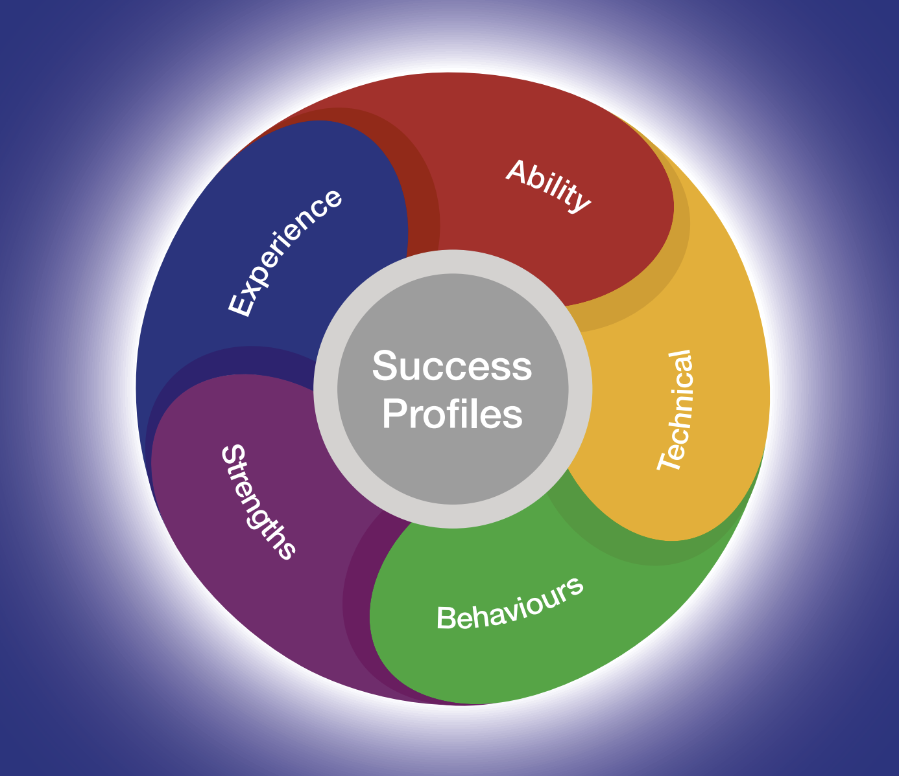

Guidance for writing your Statement and CV

As part of the application process, you need to submit a Statement and CV. Both your Statement and CV should demonstrate how you meet the essential experience and/or ability and/or technical skills outlined in the Person Specification section.
Ensure you read through the role information thoroughly and identify the essential criteria for each area. You should ensure you provide evidence for each of the essential experience and/or abilities and/or technical skills which are required for the role in your Statement and CV. You may not be progressed to the next stage of the assessment process if you do not provide this evidence.
When structuring your Statements try to:
- Group evidence of the same experience and/or abilities and/or technical skills together by using subheadings and paragraphs. This will help to ensure you are writing about the experience that is directly relevant for the role you are applying for.
- You should ensure that you detail recent and relevant examples of the essential experience and/or abilities and/or technical skills required for the role and describe the outcome that came from this.

Using AI in your application

Artificial Intelligence can be a useful tool to support your application, however, all examples and statements provided must be truthful, factually accurate and taken directly from your own experience. Where plagiarism has been identified (presenting the ideas and experiences of others, or generated by artificial intelligence, as your own) applications may be withdrawn and internal candidates may be subject to disciplinary action.

Please see our candidate guidance for more information on appropriate and inappropriate use.

Providing a name-blind CV and Success Profile Statements
In both your CV and Success Profile Statements please remove references to any personal information that could identify you. For example:
- Name and title
- Educational institution names
- Age and gender
- Email address
- Postal address and telephone number
- Nationality and immigration status.
This will help us to recruit based on your knowledge and skills, and not on your background, gender or ethnicity. Recruiting this way is called name-blind recruitment.
For more information on how to write your Statement and CV please visit the Civil Service Careers Website

Expected Timeline

We will try and offer as much flexibility as we can, but it may not be possible to offer alternative dates for assessments or interviews. You are therefore asked to note the below timetable, exercising flexibility through the recruitment and selection process, in order to meet the dates given. Please note that these dates may be subject to change.

The anticipated timetable is as follows:
Advert Closing Date | Sunday 19th July 2026
Outcome of CV and Statement of Suitability | w/c 10th August 2026
Other Assessment Stages | w/c 24th August 2026
Panel Interview and Presentation | w/c 7th September 2026

Working for the Ministry of Justice


Equality, Diversity, Inclusion and Wellbeing
Our departmental values - purpose, humanity, openness and together - are at the heart of our commitment to create a culture where all our people are able to thrive and flourish in the workplace.
We want to attract and retain the best talent from diverse backgrounds and perspectives. We want everyone to be the best of themselves, to feel supported and have a strong sense of belonging in the workplace. Our commitment to creating a diverse and inclusive workforce is reflected in all of our people policies and strategies.
Benefits
As a Ministry of Justice employee, you’ll be entitled to a large range of benefits which include but are not limited to:
Pension
The Civil Service Pension Scheme is one of the best workplace pension schemes in the UK public sector. Visit www.civilservicepensionscheme.org.uk for more details.
Generous Annual Leave and Bank Holiday Allowance
25 days annual leave on entry, increasing on a sliding scale to 30 days after 5 years’ service. This is in addition to 8 public holidays. This will be complemented by one further day paid privilege entitlement to mark the King’s Birthday.
Flexible Working
While not every type of flexible working will be suitable for every role and business area, flexible working can take many forms and The Ministry of Justice is committed to delivering its business effectively and sustainably by creating modern and inclusive workplaces that enable smart, flexible and hybrid working.
For more information on our amazing benefits including our Civil Service Pension Scheme, annual and special leave, and our Equality, Diversity, Inclusion and Wellbeing schemes please visit our Senior Civil Service website.

Disability Support

What reasonable adjustments can be made if I have a disability?
We are committed to supporting all candidates to take part in the recruitment process. This includes supporting individuals who have a disability by making reasonable adjustments to the recruitment process.
If you feel you require any kind of support and/or would like to discuss this with someone, please indicate ‘yes’ to requesting reasonable adjustments in your application form and ensure that you respond to the Reasonable Adjustments Scheme team by email.
How we can support you
There are many types of reasonable adjustments that can be made during assessment processes.
Examples of some types of adjustments include:
- Extra time to complete assessments.
- Providing a break within an assessment.
- Providing interview questions in a written format at the interview as well as orally.
- An interview at a certain time of day.

This is not an exhaustive list but rather some examples of how we can support you during the SCS Recruitment Process.

Whilst we aim to confirm all adjustments requested, there may be occasions where this isn’t possible. If an adjustment cannot be provided, the reasons for this will be explained to you.
Help with your application
It is important you contact us as early as possible by email if you would like to request reasonable adjustments so that the recruitment process runs smoothly for you.
If you do decide during the process that you do require adjustments and you have not completed all your assessments, please contact the SCS recruitment team in advance of your next assessment.
If you have any questions in advance of making your application regarding reasonable adjustments, please contact the SCS recruitment team at scsrecruitment@justice.gov.uk.
Do you offer a Disability Confident Scheme for Disabled Persons?
As a Disability Confident employer, the MoJ offer an interview to disabled candidates who meet the minimum selection criteria, except in a limited number of campaigns. This could be in terms of the advertised essential skills and/or application form sift criteria. Within the application form, you will be asked if you would like to be considered for an interview under this scheme, so please make us aware of this when prompted.
FAQs

Can I apply if I am not currently a civil servant?
Yes.
Is this role suitable for part-time working?
This role is available for full-time or job shares. To discuss your needs in more detail please get in touch with the SCS Recruitment Team.
Where will the role be based?
If successful you will be based nationally. Relocation costs will not be reimbursed.
This role will also require some travel to London.
Can I claim back any expenses incurred during the recruitment process?
Unfortunately, we will not be able to reimburse you, except in exceptional circumstances.

Am I eligible to apply for this role?
For information on whether you are eligible to apply, please visit Gov.UK.
Is security clearance required?
Yes. If successful you must hold, or be willing to obtain, security clearance to SC level. More information about the vetting process can be found here.
Will this role be overseen by the Civil Service Commission?
No. However, the recruitment process will still be governed by the Civil Service Commission’s Recruitment Principles.
What do I do if I want to make a complaint?
The law requires that selection for appointment to the Civil Service is on merit on the basis of fair and open competition as outlined in the Civil Service Commission’s Recruitment Principles.
Should you feel that the recruitment process has breached the recruitment principles and you wish to make a complaint, you should contact scsrecruitment@justice.gov.uk in the first instance.
If you are not satisfied with the response you receive from the Department, you are able to raise a formal complaint in the following order.
- To Shared Service-Connected Ltd (0845 241 5358 (Monday to Friday 08.00 – 18.00) or e-mail Moj-recruitment-vetting-enquiries@gov.sscl.com)
- To Ministry of Justice Resourcing (resourcing-services@justice.gov.uk)
- To the Civil Service Commission (https://civilservicecommission.independent.gov.uk/contact-us/)
What should I do if I think that I have a conflict of interest?
If you believe that you may have a conflict of interest you must declare it by contacting SCS Recruitment on scsrecruitment@justice.gov.uk before submitting your application.
Data Sharing

We will ensure that we will treat all personal information in accordance with data protection legislation, including the General Data Protection Regulation and Data Protection Act 2018.
Data Sharing
To process your application your personal data will be shared with the Ministry of Justice SCS Recruitment Team, campaign Panel Members and anyone else necessary as part of the recruitment process.
The legal basis for processing your personal data is:
Processing is necessary for the performance of a task carried out in the public interest. Personal data are processed in the public interest because understanding civil servant experiences and feelings about working in the Civil Service can inform decision taken to improve these experiences, and ultimately organisation performance.
Sensitive personal data is personal data revealing racial or ethnic origin, political opinions, religious or philosophical beliefs, or trade union membership, and the processing of genetic data, biometric data for the purpose of uniquely identifying a natural person, data concerning health or data concerning a natural person's sex life or sexual orientation.
The legal basis for processing your sensitive personal data is:
- Processing is necessary for reasons of substantial public interest for the exercise of a function of the Crown, a Minister of the Crown, or a government department: it is important to know if groups of staff with specific demographic characteristics have a better or worse experience of working for the Civil Service, so that appropriate action can be taken to level this experience;
- Processing is of a specific category of personal data and it is necessary for the purposes of identifying or keeping under review the existence or absence of equality of opportunity or treatment between groups of people with a view to enabling such equality to be promoted or maintained.
- Please note if you are successful in your application your sensitive personal data will be used as part of the on-boarding process to build your employee record.
For further information please see the GDPR Privacy Notice.
Diversity & Inclusion

The Civil Service is committed to attract, retain and invest in talent where it is found. To learn more, please see the Civil Service People Plan and the Civil Service D&I Strategy



Contact us
Should candidates like to discuss the role in more detail before submitting an application, please contact SCS Recruitment on scsrecruitment@justice.gov.uk.

