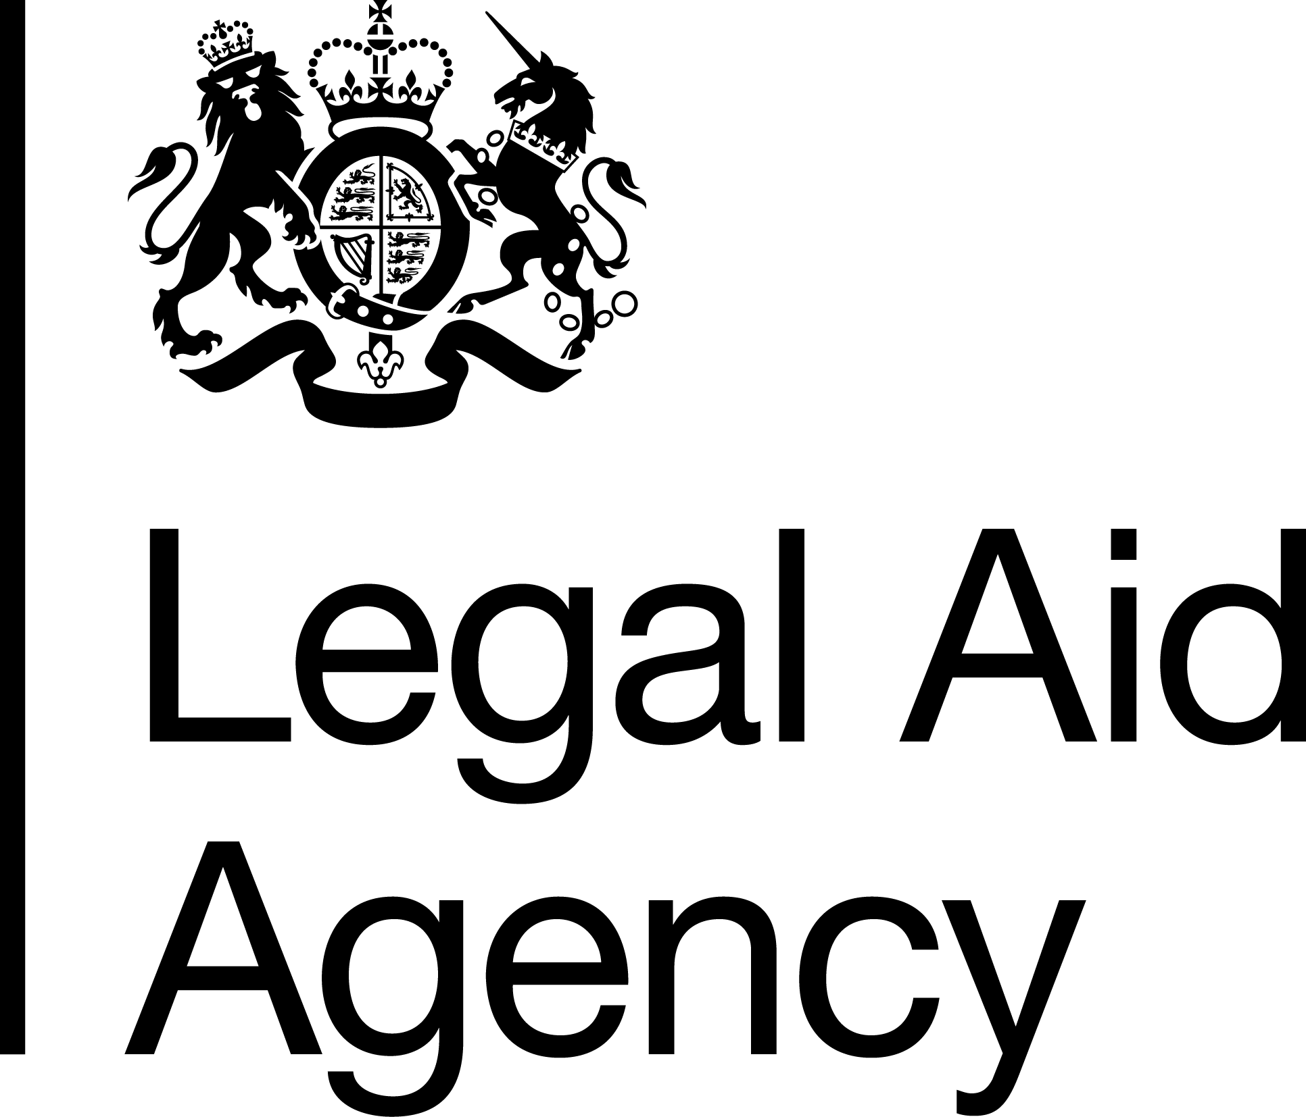

Job Title & Grade: Organisation Design Officer, SEO
Contract Type: Detached Duty / Loan – 24 months
Salary range (depending on location):
National - £42,914 - £46,182
London - £49,325 - £53,081

Please note that unless you are currently employed by the Civil Service and are earning more than the minimum above, if successful you will be offered the minimum for the grade depending on your location.

Location: National (any LAA office)
Please note that whilst this role is open to all Civil Service staff, you can only apply for London, Cambridge and Brighton offices if you are a current LAA staff member based in those offices. This is due to and in line with the LAA's Location Strategy and the Cabinet Office's Places for Growth Strategy.

Minimum Working Pattern:

If you are applying for a part time role, please note that to meet business demands we need cover for a minimum of 30 hours per week.

The Legal Aid Agency
We are an executive agency of the Ministry of Justice (MoJ). We are responsible for operationally administering the legal aid fund to provide criminal and civil legal aid advice to people in England and Wales.
Our people are at the heart of achieving excellence. Employing around 1,200 colleagues across England and Wales, we feel proud to have some of the best People Survey results in the Civil Service.

Corporate Services
The Corporate Services directorate works across the LAA to help shape and enable the priorities of the Chief Executive and Executive Leadership Team, providing support on areas such as strategy, data analysis, risk, assurance, communications, people and capability to all other parts of the LAA.

People and Capability
The People & Capability Team oversee the implementation and delivery of the LAAs People Strategy, the annual People Survey and delivery of actions within the People Plan, the LAA’s learning and development offer, capability, talent, management support, recruitment, diversity and inclusion.
The People and Capability Team play a key role in helping us to deliver our People Strategy objective to become an inclusive and diverse employer of choice.

Job Summary
Join us to shape how the Legal Aid Agency transforms its workforce. As an Organisation Design Officer, you will play a key role in helping the LAA design effective structures, build capability, and ensure our workforce is aligned to deliver legal aid services across England and Wales. You will work with senior leaders to analyse workforce challenges, design solutions, and support major organisational change. This includes redesigning structures, processes and governance arrangements to ensure they are aligned with our strategic objectives and enable high quality service delivery.
Using your experience in organisational design and development (the process of aligning an organisation's structure, processes, and roles with its goals to improve efficiency and performance), behaviour change and continuous improvement, you will advise and coach project teams to modernise ways of working, streamline end to end processes and embed sustainable change that makes work simpler, faster and better for our people and those we serve.
The role will help ensure the LAA’s organisational structures, capability and workforce planning support delivery of strategic priorities, enabling us to provide high-quality legal aid services to those who need them most.
This is a fixed-term opportunity for 2 years requiring the ability to manage multiple stakeholders, quickly understand the operating environment, and navigate the challenges of a whole system transformation effort across legal aid.
This role offers the opportunity to develop expertise in organisational design, workforce planning and organisational change, while working closely with senior leaders across the Legal Aid Agency.
Key Responsibilities:
- Lead and deliver organisational design activity, working with stakeholders to diagnose issues, define requirements and deliver high quality design interventions that support LAA and MoJ priorities.
- Provide organisational design support to legal aid change and transformation programmes, including restructuring teams, redesigning governance, and improving end‑to‑end processes to enable effective future operating models.
- Support the development of high level and detailed operating model designs, ensuring alignment with strategic objectives, workforce plans and service delivery needs.
- Support ongoing, iterative change towards the target operating model, monitoring progress, and identifying risks or barriers
- Apply analytical capability to organisational challenges, generating insight from data, evidence and best practice, and translating this into clear options and actionable recommendations.
- Coach and advise leaders and project teams, bringing expertise in organisational development, behaviour change and continuous improvement to build their capability and support effective decision making.
- Other work as required to support business effectiveness
Essential Knowledge, Experience and skills
- Experience of all stages of the organisation design process (Including organisation capabilities, designing future ‘to be’ design options, scenario testing, detailed design options).
- Experience analysing organisational or workforce information to identify improvement opportunities.
- Ability to work with senior stakeholders and influence decision making.
- Strong analytical and problem-solving skills.
- Experience supporting organisational change, workforce planning or service improvement activity.
- Ability to communicate complex information clearly to a range of audiences.
Desirable Knowledge, Experience and skills
- Organisation Design qualification, change management qualification, significant commitment to personal and professional development.
Person Specification
- You’ll work well with people and be able to maintain positive relationships whilst ensuring objectives are met.
- You’ll enjoy working in both a pro-active and re-active way, to be able to reprioritise effectively.
- You’ll have strong analytical and project management skills.
- You’ll have effective facilitation and communication skills.
- You’ll be fluent in PowerPoint and Excel.

Assessment Approach

Application Process
To apply please submit a CV and statement of suitability showing how you meet the essential criteria in no more than 1250 words.

Your statement should demonstrate your ability to do all the essential criteria listed, using examples can help strengthen your application.

If you meet most of the criteria but not every requirement, we would still encourage you to apply.
Please note that we only require a CV & Statement of Suitability for your application. The wording on this advert may suggest that an Experience question is also required, however this is not necessary.

Interview / assessment Process

If you are successful through the application stage, you will be invited to an interview / assessment centre in person or via Microsoft Teams where you will be assessed against the following:

Strengths relevant to the role
The following Behaviours:
- Changing & Improving
- Seeing the Big Picture
- Leadership
- Communicating & Influencing

Your Experience of implementing, promoting, or understanding diversity and inclusion policy - Diversity is the presence of difference, this can include one or more of the protected characteristics (Gender, Age, Race, Disability etc.) or it can be about working patterns, whether we like to jump into a task or reflect on it before acting. Inclusion is how we welcome, value, and celebrate diversity, giving everyone a voice, tapping into ideas, and enabling everyone to be themselves at work and achieve their potential.

For this grade/ role we would expect the candidate to demonstrate understanding of the terms Diversity and Inclusion and be able to explain why they are important in a work environment. We would also expect examples of action they have taken to embrace diversity (e.g., increasing understanding for self or others) or improve inclusion at a team or wider group level.

There will be a short presentation assessed against your experience of all stages of the organisation design process (including organisation capabilities, designing future ‘to be’ design options, scenario testing, detailed design options). Full details will be provided to you within your Microsoft Teams interview invite.

Shortlisting is planned for week commencing 13th July 2026
Interviews are planned for week commencing 27th July 2026
If you would like more information on this opportunity, please contact – Paula Mulroy at paula.mulroy@justice.gov.uk

Our LAA commitment to Diversity and Inclusion
The Civil Service is committed to attract, retain, and invest in talent wherever it is found. To learn more please see the Civil Service People Plan and the Civil Service Diversity and Inclusion Strategy.
As a Disability Confident organisation, we will offer a guaranteed interview to candidates with a disability who meet the essential criteria for this role. Under the Equality Act 2010 a disability is defined as a physical or mental impairment which has a substantial and long-term adverse effect on your ability to carry out normal day-to-day activities which has lasted, or is expected to last, at least 12 months.
If you are responding to a role within the Legal Aid Agency and would like to be considered under the guaranteed interview, please indicate this in your application and let us know of any reasonable adjustments you may require during the sift or later selection processes.
The LAA’s goal is to build an organisation that is open and inclusive and truly values and celebrates the diversity of its workforce. One that reflects and understands the needs of the diverse society we serve. This is regardless of social background, gender, age, ethnicity, sexual orientation, beliefs, disabilities or long-term illness or caring responsibilities.
Reasonable Adjustments
We are committed to ensuring our recruitment process is inclusive and accessible to all. If you have a disability or long-term condition (for example dyslexia, anxiety, autism, a mobility condition or hearing loss) and need us to make any reasonable adjustments to support you through the recruitment process, please let us know by adding the information to the applications system or emailing LAARecruitment@justice.gov.uk after you have applied so that we can discuss options with you.


Complaints procedure
If you have any complaints about this recruitment activity, please share your concerns by emailing LAARecruitment@justice.gov.uk initially. We aim to respond to any complaint within 10 working days.

