Head of Professional Delivery Group
Project Delivery Function
SCS Pay Band 1
Closing Date: 23:55 19th July 2026

About the Ministry of Justice
The Ministry of Justice is at the centre of the justice system, with responsibility for services that are fundamental to public confidence, the rule of law and the effective functioning of society. We lead work that protects the public, supports victims, safeguards rights and enables individuals, families, communities and businesses to access justice fairly and efficiently.

As a major ministerial department, the Ministry of Justice works to protect and advance the principles of justice. Our ambition is to deliver a modern, high-performing justice system that commands confidence, responds to changing demands and works for everyone in society.
The department’s work has profound national significance. It helps keep people safe, underpins fairness and due process, protects individual rights and supports the confidence on which economic activity and social stability depend. Across this broad and complex portfolio, our priorities focus on delivering better outcomes for the public through three core strategic aims:
- Protecting the public and reducing reoffending by strengthening prison, probation and youth justice services so that punishment is effective, rehabilitation is credible and communities are safer.
- Delivering swifter and more effective justice for victims and court users through modern, efficient and resilient courts and tribunals services.
- Upholding the rule of law and sustaining a justice system that is accessible, fair and outward-looking, while supporting world-leading legal services and wider economic growth.
For further information about the Ministry of Justice and the breadth of its work, please visit: Ministry of Justice
Welcome to the Ministry of Justice Project Delivery Function

Thank you for your interest in this opportunity with the Project Delivery Function.



The Ministry of Justice (MoJ) is a leading Project Delivery Department in Government. We build new prisons, transform the justice system and upgrade IT technologies.
As Head of the Professional Delivery Group, you will lead the c.300-375 project delivery professionals, who are then assigned to projects and programmes across the Ministry of Justice and its agencies.
Your key challenge will be to provide sufficient project delivery professionals. We need to ensure that our teams are diverse, and our climate is inclusive, so that we reflect the society we serve. You will be a people person, with a passion for Project Delivery, and be able to negotiate with and influence your key clients: SROs and Project/Programme Directors.
This is a unique opportunity to work at the heart of the MoJ, directly contributing to the successful delivery of one of the largest and broadest portfolios across Government. We welcome applications from high-calibre individuals who can build and lead a high performing and inclusive team, and work with a wide range of stakeholders to deliver and add value.
Best wishes,
Jon Griffiths
Chief Project Delivery Officer

About the Project Delivery Function
The MoJ Project Delivery Function (PDF) undertakes and oversees all project delivery activity within the Ministry of Justice.
We do this by:
- Providing project professionals and project delivery services to the MoJ, its agencies and Arms Length Bodies (ALBs).
- Providing oversight of the MoJ Portfolio of Change to make sure it is achievable and affordable and to ensure it remains aligned to the Justice Delivery Plan.
- Ensuring compliance with the Project Delivery Functional Standard and empower all project professionals to ensure adherence to the Functional Standard.
- Engaging with other government departments, the National Infrastructure and Service Transformation Authority (NISTA) and the Association for Project Management (APM), to improve the PDF and profession across MoJ.
- Overseeing development programmes for our future project leaders in MoJ.
- Upskilling our project delivery professionals to ensure they have the right tools, experience and capability to deliver MoJ’s Justice Delivery Plan.
The PDF is transforming itself to ensure we are well positioned to meet future demand, strengthen our senior leadership and continue to improve delivery confidence, assurance and capability across the MoJ.

The Role

Job Title
Head of Professional Delivery Group
Location
National: The MoJ is working to open more Justice Collaboration Centres and Justice Satellite Offices over time. Click here to learn more about where our currently open Justice Collaboration Centres and Justice Satellite Offices are, to identify where you may be based.

Please note the requirements for travel and level of flexibility available as set out in the FAQs section.

All successful candidates will be appointed to the nearest viable office nearest to their home postcode. This will be at either an HQ building (subject to desk allocation), a JCC or JSO - See Map .

All employees will be expected to spend a minimum of 60% of their working time in an office, (subject to local estate capacity). The MoJ is working to open more Justice Collaboration Centres and Justice Satellite Offices over time.
Salary
The salary for this role is set within the MoJ SCS PB1 range (£86,000 - £99,000).
Existing Civil Servants will be appointed on level transfer or promotion in line with Civil Service pay arrangements. On promotion, salary will increase either to the minimum of the SCS Pay Band 1 range or by up to 10% of current basic salary, excluding allowances, whichever is greater. Candidates appointed on level transfer will retain their existing basic salary, excluding allowances.
Contract Type
This role is offered on a permanent basis.
This role has an expected minimum assignment duration of three years, reflecting the deliverables identified. This is an expectation rather than a contractual requirement and does not form part of your terms and conditions.

If applying as job share partners, please review the guidance here; hub page | Civil Service Careers (civil-service-careers.gov.uk)

Security Clearance
Successful candidates will be required to obtain SC level clearance
The Role
- As Head of the Professional Delivery Group, you will be responsible for leading the large and geographically dispersed resource pool of project professionals in the Professional Delivery Group (PDG) in the multi-mixed matrix model, where there is a combination of matrix and team-based line management. You will drive the delivery of projects and programmes across the MoJ where they are assigned. You will do this by creating a culture of high performing Project Delivery professionals, directly accountable for ensuring they have the capability to deliver and comply with best practice and Project Delivery (PD) Functional Standards across the PDG.
- You will have a passion for Project Delivery and the personality to lead and influence stakeholders. You will be articulate with data and embrace Artificial Intelligence.
- You will build strong relationships with SROs across the MoJ. You will also build your network across MoJ and more widely with the National Infrastructure and Service Transformation Authority (NISTA), other Government Departments, professional bodies and the Project Delivery sector.
- This is a unique opportunity to work at the heart of MoJ directly contributing to the successful delivery of one of the largest portfolios of major projects and programmes across Government.
- We welcome applications from high-calibre individuals who can use their experience to build a high performing team and work with a wide range of stakeholders to deliver services that add value.
- The role reports to the Chief Project Delivery Officer, working alongside the Portfolio Director, Head of Project Assurance & Governance and Head of Profession as an integral part of the Senior Leadership Team.
Key Responsibilities
- Be accountable for the leadership of four/five clusters totalling c.300-375 FTE project delivery professionals in PDF's Professional Delivery Group.
- Drive delivery of projects and programme through the line, with effective first line controls, ensuring project delivery best practice and compliance with Functional Standards on a 'comply or explain' basis.
- Enable an increase in capability of the Project Delivery professionals in your clusters through the provision of courses, learning opportunities, professional accreditation and Chartership, in accordance with the Project Delivery Capability Framework.
- Ensure effective resourcing of project and programmes based on capability and fully recharged, efficient recruitment and onboarding, robust workforce planning and demand forecasting, and oversee PD consultancy and Contingent Labour contracts to minimise external spend.
- Ensure the successful implementation and embedding of the Transformation Plan to deliver its outcomes and cultural change to improve project performance, embed best practice and enable improvements in resourcing and capability.
- Engage with SROs across the department and with other senior stakeholders to ensure robust demand forecasting, resource provision and professional support and build strong relationships with senior stakeholder in NISTA and across Government.
- Deliver PDF Objectives, Business/ Transformation Plan outcomes, Outcomes & Key Results (OKRs) and Key Performance Indicator (KPI) targets as a joint endeavour and specifically those relating to compliance with functional standards, capability and resourcing.
- Collaborate with the other members of the Senior Leadership Team, bringing your perspective from your area of expertise and responsibilities to produce a cohesive and collective functional view, represented effectively at Departmental Committees and senior boards.
- Respond effectively to changing Departmental priorities.
- Effectively lead a geographically dispersed team.
Collective Responsibilities
You will work collaboratively with the Senior Leadership Team and have collective responsibility for key areas of delivery to successfully deliver our shared outcomes. This shared responsibility is required to ensure accurate insights into project performance, adherence to professional standards, resource prioritisation and delivery of business and Transformation Plan priorities.

Organogram

Person Specification

Throughout the selection process, you should provide clear evidence and examples that demonstrate how you meet the essential and desirable criteria for the role.
Later in this pack, you will find details of which elements will be assessed at each stage of the process, helping you focus your application and prepare effectively.



Essential Experience:
NB: In the event we receive a high volume of applications, we will conduct the initial sift against the following lead criteria in bold:
- Proven success in leading projects and the delivery of Project Delivery services (leadership, resourcing, and development of Project Delivery professionals) in an environment of similar scale and complexity.
- Exercise sound judgment in providing strategic advice, constructive challenge and support to the business in the field of Project Delivery and Project Delivery services.
- Build strong stakeholder relationships at all levels and navigate politically sensitive and complex issues and negotiations.
- Work seamlessly across boundaries, collaborating with and drawing on resources from across MoJ, Government and externally.
- Experience of developing high performing teams and providing inspirational leadership, with strong communication and engagement.
- Experience in Human Resources policies and practices.
- Passion for developing the Project Delivery profession across Government. This is a high-profile role at an exciting period in the development of the Project Delivery Function in the Ministry of Justice.
Desirable Experience:
- Hold Project Delivery qualifications or be willing to work towards them (e.g. PRINCE2, APM PMQ, Chartered Project Professional, Project Delivery Accreditation).

MoJ SCS Pay Band 1 Behaviours:
You will also be assessed against the following Behaviours during the Recruitment Process:
- Leadership
- Managing a Quality Service
- Communicating and Influencing
- Developing self & others
- Working together
Strengths
We are looking to understand what motivates and energises you. We want to see what your natural strengths are and what interests you.
Strengths may be assessed at interview, but these are not shared in advance.
Civil Service Leadership Statement:
All leaders within the Civil Service are expected to demonstrate the qualities within the Civil Service Leadership Statement during their Staff Engagement Exercise.

The Recruitment Process

Recruitment Process
The selection process will be chaired by Jon Griffiths, Chief Project Delivery Officer, Project Delivery Function. The other panel members will be:
- Gary Badley CBE, Senior Responsible Owner, Property Transformation Programme, Ministry of Justice,
- Louise Emmerson-Ducasse, Head of Profession, Project Delivery Function, and
- Robert Nicholas, Portfolio Director, Project Delivery Function.
Support during the selection process
If you need support or would like to discuss any aspect of the process, please contact the SCS Recruitment Team at scsrecruitment@justice.gov.uk. We are here to help candidates engage with the process confidently and fairly.
Stages of the selection process
Application
Applications must be submitted online via the link in the advertisement for this role.
Applications must be received by 23:55 on 19th July 2026. As part of your application, you will be asked to provide:
Eligibility responses confirming that you meet the requirements to apply.
An indication of whether you wish to request reasonable adjustments during the selection process. The Disability Support section explains the support available.
- A CV and Statement of Suitability setting out clear evidence of how you meet the essential experience set out on page 9. The Statement of Suitability should be no more than 1250 words.
- Please note that if you do not submit both a CV and a Supporting Statement, the panel may have insufficient evidence on which to assess your application against the person specification.
NB: In the event we receive a high volume of applications, we will conduct the initial sift against the following lead criteria:
- Proven success in leading projects and the delivery of Project Delivery services (leadership, resourcing, and development of Project Delivery professionals) in an environment of similar scale and complexity.
Find out more information and guidance on our application process here.
After the Application Stage
You will be informed whether your application has been shortlisted for the next stage. If shortlisted, we will contact you with full details of the next part of the process and any preparation required.
Due to the anticipated volume of applications, we are unable to provide feedback to candidates who are not shortlisted. Candidates who are shortlisted and attend interview will be offered verbal feedback from a member of the panel.
Internal Stakeholder Conversations
Shortlisted candidates are invited to arrange an informal conversation with Jon Griffiths to learn more about the opportunity and the organisation.
Assessments
Staff Engagement Exercise
The Staff Engagement Exercise (SEE) gives you the opportunity to lead a two-way discussion with a group of staff on a topic that will be shared with you in advance. An Occupational Psychologist will brief you beforehand, observe the discussion and facilitate feedback from participants. Their observations, together with participant feedback, will inform the panel’s overall assessment.
What is being assessed?
The Civil Service Leadership Statement.
These assessments are not pass or fail. They are intended to provide additional insight into your leadership profile, support your understanding of the role and organisation, and help the panel identify areas for further exploration at interview.
Panel Interview and Presentation
You will be invited to attend an interview and presentation with the selection panel. You will be asked to prepare a verbal 5-minute presentation based on a topic that will be provided in advance. The interview and presentation is expected to take approximately 45 minutes.
What is being assessed?
Behaviours, as listed on page 10.
Strengths
You will be informed at interview which strengths you are being assessed against.
After the Panel Interview
Following the interview stage, the panel will consider all evidence and identify the appointable candidate. Candidates will be notified of the outcome as soon as possible after interviews conclude. If you are not appointed but meet the required standard, you may be invited to have your details retained on a merit list for future SCS1 roles.

Guidance for Writing your Statement and CV

As part of your application, you will be asked to submit a CV and Statement of Suitability. Together, these should provide clear evidence that you meet the essential criteria set out in the Person Specification.
Read the role information carefully and address each essential criterion with relevant evidence. Focus on your most significant and recent achievements, making clear the context, scale of your contribution and the impact you delivered.
When preparing your Statement of Suitability, it may help to:

- Present your evidence clearly so the panel can see how your experience aligns to the essential criteria.

- Use recent, relevant examples that show the scale of your responsibilities, the complexity you handled and the outcomes you achieved.
Using AI in your application
Artificial Intelligence may help you shape or refine your application, but everything you submit must be accurate, authentic and based on your own experience. Examples should reflect your personal contribution and judgement. Applications may be withdrawn where content is misleading, plagiarised or not the candidate’s own work. Internal candidates may also be subject to disciplinary action.

Please see our candidate guidance for more information on appropriate and inappropriate use.

Providing a name-blind CV and Success Profile Statements
Please ensure your CV and Statement of Suitability are name blind. Remove personal information that is not relevant to the assessment of your suitability for the role, for
example;

- Name and title
- Educational institution names
- Age and gender
- Email address
- Postal address and telephone number
- Nationality and immigration status.

This supports a fair and objective assessment by enabling the panel to focus on your evidence, capability and potential rather than personal identifiers.

For more information and guidance on how to write your Statement and CV please visit the Senior Civil Service web page.

Civil Service Behaviours

What are Behaviours?
The Civil Service recruits using Success Profiles. Behaviours are one element of that framework and help assess how candidates demonstrate the leadership qualities, judgement and ways of working needed to succeed in the role.
For this campaign, the behaviours most relevant to the role will be assessed during the interview stage of the process. The descriptions below are included to help you understand what each behaviour looks like in practice.
Communicating and Influencing
You communicate clearly and with confidence, both verbally and in writing. You are open, honest and transparent in your communications. You communicate effectively with internal and external senior stakeholders to present information in a convincing and influential manner. You tailor your communication methods and content to the audience, simplifying strategic messages.
Leadership
You visibly demonstrate the organisation’s values in all your activity, leading authentically. You seek to engage staff in the aims of the organisation and communicate the organisation’s strategy in an inspiring way. You create an inclusive and fair culture which creates a sense of belonging by treating staff as individuals and actively valuing diversity within the organisation. You empower teams and individuals to excel by creating a shared vision and objectives and demonstrate trust in staff by giving autonomy.
Working Together
You work collaboratively to achieve outcomes both within your area of responsibility and across the organisation. You create a supportive working environment where all opinions are considered, and individuals are valued for their expertise and unique contribution. You proactively maintain relationships with peers and external senior stakeholders and utilise these to achieve positive outcomes.
Developing Self and Others
You hold a genuine belief in the importance of development for yourself and others. You have a clear understanding of your strengths and development areas. You take an active role in staff development by identifying development opportunities, providing positive and constructive feedback. You take a future-focused approach to development considering succession planning and recognising the benefits of developing staff outside your own area. You recognise under-performance and contribute to the resolution of it. You use your own expertise to provide coaching and mentoring to support staff to succeed.
Managing a Quality Service
You understand the requirements of service users and are focussed on providing a service that offers the best outcomes for the public. You foster an environment where opportunities to improve service delivery are identified and adjust processes accordingly. You create plans and consider the resources needed to support implementation. You identify risks and barriers to service delivery and ensure they are removed.
For further guidance on Behaviours and Success Profiles, please visit our Senior Civil Service web page.

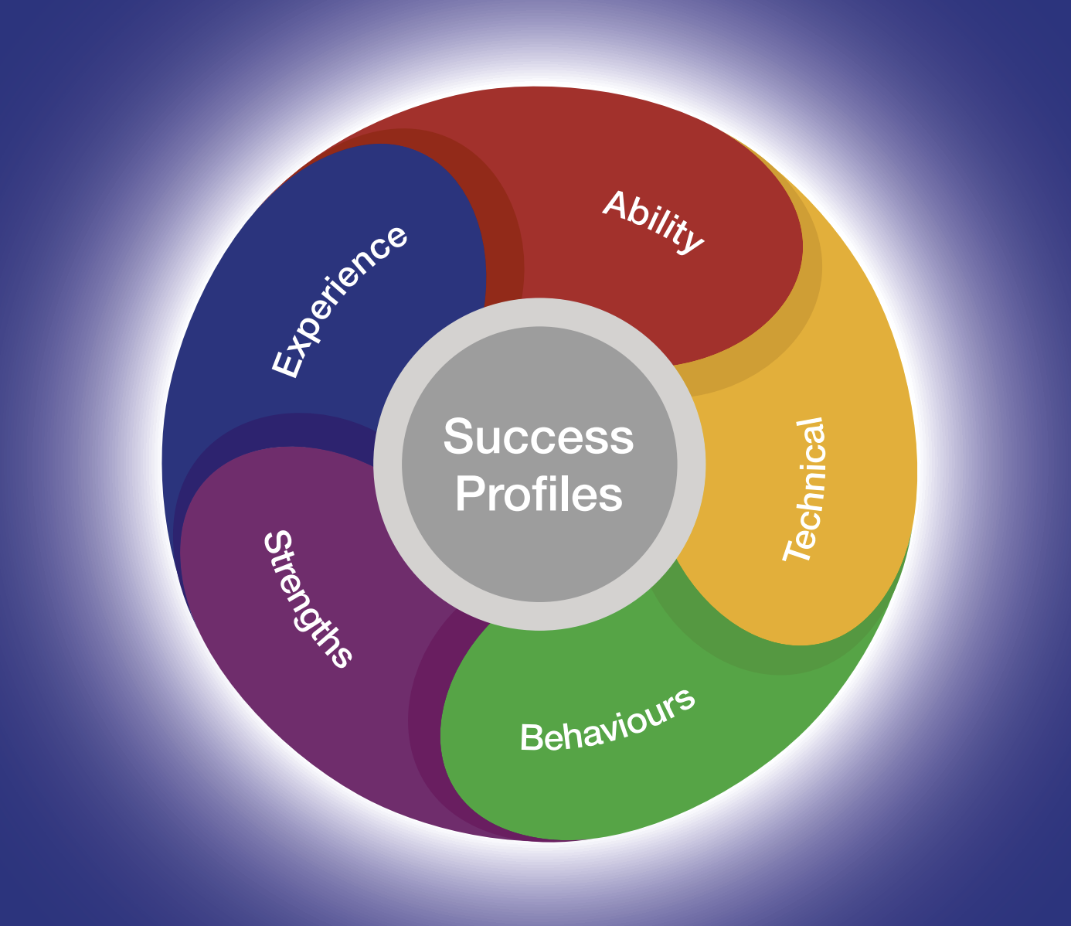

Expected Timeline

We will aim to offer as much flexibility as possible; however, it may not always be feasible to provide alternative dates for assessments or interviews. We therefore encourage candidates to review the timetable carefully and keep the relevant dates available where possible. Please note that the timetable may be subject to change.

The anticipated timetable is as follows:
Advert Closing Date | 19th July 2026
Outcome of CV and Statement of Suitability | Week Commencing 10th August 2026
Assessments | 19th August 2026
Panel Interview and Presentation | 28th August 2026

Working at the Ministry of Justice


The Civil Service Code
The Civil Service Code sets out the values and standards expected of all civil servants. Issued by the Prime Minister as Minister for the Civil Service, it is founded on four core principles—integrity, honesty, objectivity and impartiality—and forms part of the contractual relationship between civil servants and their employer.

Equality, Diversity, Inclusion and Wellbeing
The Ministry of Justice offers senior leaders the opportunity to lead work of national importance in an organisation defined by public purpose, integrity and visible impact. Our values—purpose, humanity, openness and together—shape a culture of pace, integrity and inclusive leadership. We are committed to a diverse, high-performing workplace that reflects the society we serve, where different perspectives, wellbeing, belonging and sustainable leadership matter.
Benefits
As part of the Ministry of Justice, you will benefit from a competitive package that supports your wellbeing, flexibility and longer-term career development, including:
Pension
You will have access to the alpha pension scheme, which includes a 28.97% employer contribution and comparatively low member contributions by public sector standards.
The Civil Service Pension Scheme is a significant part of the overall reward package, offering long-term security and valuable benefits for you and your family. Further details are available at www.civilservicepensionscheme.org.uk.
Generous Annual Leave and Bank Holiday Allowance
You will receive 25 days’ annual leave on entry, rising to 30 days after five years’ service, in addition to 8 public holidays and a day of paid privilege leave to mark the King’s Birthday.
Flexible Working
We support flexible and hybrid working where this aligns with the needs of the role and the business, helping leaders balance impact, collaboration and personal wellbeing.
Further information on benefits, including pension, leave and Equality, Diversity, Inclusion and Wellbeing support, is available on our Senior Civil Service web page.

Disability Support

Do you offer a Disability Confident Scheme for Disabled Persons?
As a Disability Confident employer, the Ministry of Justice is committed to creating a recruitment process that is fair, accessible and inclusive. In most campaigns, disabled candidates who meet the minimum selection criteria will be offered an interview. You will be able to indicate on the application form whether you would like to be considered under this scheme.
What reasonable adjustments can be made if I have a disability?
We want every candidate to be able to take part in the selection process on a fair and equitable basis. For senior roles, that means giving you the opportunity to demonstrate your experience, judgement and leadership capability fully, with reasonable adjustments in place where needed.
If you would like to request support or discuss an adjustment in confidence, please indicate this on your application form by selecting ‘yes’ to reasonable adjustments and responding to the Reasonable Adjustments Scheme team by email. We encourage you to raise any requirements as early as possible so that arrangements can be put in place in good time.
How we can support you
A range of reasonable adjustments can be considered across the selection process, depending on your circumstances and the nature of the assessment. Our aim is to work with you to identify support that enables you to take part with confidence and on an equal footing.

Examples may include:
- Extra time to complete assessments.
- Providing a break within an assessment.
- Providing interview questions in a written format at the interview as well as orally.
- An interview at a certain time of day.

These examples are illustrative rather than exhaustive. Appropriate support will depend on your individual circumstances, and each request will be considered thoughtfully and on its own merits.

We will make every reasonable effort to provide the adjustments requested. Where a particular adjustment is not possible, we will explain this clearly and work with you to explore appropriate alternatives wherever we can.
Help with your application
If you think you may need an adjustment, we encourage you to contact us as early as possible so arrangements can be made with sufficient notice and support can be tailored to your needs.
If your circumstances change during the process, or you identify a need for support after applying, please contact the SCS Recruitment team in advance of your next assessment wherever possible.
If you have any questions before applying about reasonable adjustments, please contact the SCS Recruitment team at scsrecruitment@justice.gov.uk. We will be happy to help.

Diversity and Inclusion

At the Ministry of Justice, we believe inclusive, respectful and high-performing workplaces are essential to delivering better outcomes for the public.
We want talented people from every background to feel welcomed, valued and able to succeed here.
That commitment shapes how we recruit, develop and support our people—and helps create an environment where diverse perspectives strengthen leadership, decision-making and impact.


We know the strongest leadership teams reflect the diversity of the society they serve. That is why we are committed to building an inclusive Civil Service where talented people from all backgrounds can thrive, contribute and lead with confidence.
Our Diversity and Inclusion Strategy focus on creating a Civil Service that:
- draws on the broadest possible range of talent, experience and perspective
- is visible, accessible and open to people from all backgrounds
- supports flexible, inclusive ways of working that help people and performance flourish
- attracts, develops and retains exceptional leaders at every stage of their career
For executive candidates, this means joining an organisation that values inclusive leadership, sees difference as a strength, and is committed to creating the conditions for diverse talent to succeed, influence and shape outcomes of national importance.

FAQs

Can I apply if I am not currently a civil servant?
Yes. This role is open to both internal and external applicants.
Is this role suitable for part-time working?
This role is offered on a full-time basis. Flexible working options, including job share, may be considered where they align with business need.
Where will the role be based?
If successful you can be based nationally. Relocation costs will not be reimbursed.
This role will also require frequent travel to one of the Ministry of Justice Headquarters office(s), usually London or Leeds.
Please note that relocation expenses will not be payable.
Can I claim back any expenses incurred during the recruitment process?
Expenses incurred during the recruitment process will not usually be reimbursed, except in exceptional circumstances.
Am I eligible to apply for this role?
For further guidance on eligibility to apply for this role, please refer to GOV.UK.
Is security clearance required?
Yes. If successful, you will be required to obtain security clearance to SC level, if you do not already hold it. Further information about the vetting process can be found here.
Will this role be overseen by the Civil Service Commission?
No. However, this recruitment campaign will be conducted in accordance with the Civil Service Commission’s Recruitment Principles.
What do I do if I want to make a complaint?
All appointments to the Civil Service must be made on merit, on the basis of fair and open competition, and in line with the Civil Service Commission’s Recruitment Principles.
If you believe these principles have not been followed and wish to make a complaint, you should first contact scsrecruitment@justice.gov.uk.
If you are not satisfied with the response, you may escalate your complaint in the following order:
- Shared Services Connected Ltd (0845 241 5358, Monday to Friday, 08:00 to 18:00, or (Moj-recruitment-vetting-enquiries@gov.sscl.com)
- Ministry of Justice Resourcing (resourcing-services@justice.gov.uk)
- Civil Service Commission (civilservicecommission.independent.gov.uk/contact-us)
What should I do if I think that I have a conflict of interest?
If you believe you may have a conflict of interest, you must declare this before submitting your application by contacting the SCS Recruitment team at scsrecruitment@justice.gov.uk.

Data Sharing

We will handle your personal information with care and in line with applicable data protection law, including the UK General Data Protection Regulation and the Data Protection Act 2018.
Data Sharing
To administer your application, your personal data will be shared only with the Ministry of Justice SCS Recruitment Team, panel members and others directly involved in the recruitment process where necessary.
The legal basis for processing your personal data is:
- Processing is necessary for the performance of a task carried out in the public interest. In practice, this supports the fair and effective administration of recruitment and helps the Civil Service improve candidate and employee experience.
- Sensitive personal data includes information such as racial or ethnic origin, religious beliefs, trade union membership, health data and other special category data protected by law.
- Processing may be necessary for reasons of substantial public interest, including the exercise of functions by the Crown, a Minister of the Crown or a government department, and to understand whether different groups experience the Civil Service differently so that appropriate action can be taken.
- Processing may also be necessary to identify or review equality of opportunity and treatment between groups, with a view to promoting or maintaining that equality.
- If you are successful, relevant sensitive personal data will also be used during onboarding to create your employee record.
- For further information please see the GDPR Privacy Notice.

Contact Us

Should candidates wish to discuss aspects of the recruitment process please SCS Recruitment on scsrecruitment@justice.gov.uk

