Deputy Director, Rights and Public Law
Ministry of Justice
SCS Pay Band 1
Closing Date: 23:55 21st June 2026

Introduction
The Role
Person
Specification
Benefits
Recruitment
Process
FAQs
Diversity &
Inclusion
Contact Us

Welcome to the Ministry of Justice

Thank you for your interest in this exciting role in the International, Rights & Constitutional Policy Directorate



The Ministry of Justice (MoJ) is a major Government department with a vital role, working to deliver punishment that cuts crime and swifter justice for victims, and to be a beacon for justice and the rule of law.
The Rights and Public Law Division sits at the heart of the work on the rule of law, encompassing a number of complex legal policy responsibilities including human rights, closed material procedure and judicial review. We are therefore looking for a confident and experienced policy leader to fill this critical role, ideally also with some form of legal background and/or relevant subject-matter knowledge.
This is a demanding role that requires significant personal resilience and pastoral care for the team given the pace and unpredictability of work and the high exposure to political, press and stakeholder interest. It requires representational abilities domestically and internationally, and an ability to respond rapidly to new challenges while maintaining a focus on longer-term priorities.
But in return, it offers involvement in some of the most difficult and interesting issues across Government, a high level of ministerial visibility, and a role in shaping this country’s constitutional framework.
MoJ is committed to promoting equality and valuing diversity. Having a diverse senior team at MoJ is important to us. We need and value people from different backgrounds with different perspectives.
If you believe you have the skills and qualities for this role, I would therefore be delighted to hear from you.
Best wishes,
James Dowler
Director, International, Rights & Constitutional Policy

About the Ministry of Justice

The Ministry of Justice is a major government department at the heart of the justice system. We deliver some of the most fundamental public services including courts, tribunals, prisons, legal services, youth justice, probation services, and attendance centres.

The Ministry of Justice (MoJ) works to protect and advance the principles of justice. Our vision is to deliver a world-class justice system that works for everyone in society.
The justice system plays a crucial role in our success as a nation – keeping people safe, emphasising fairness, guaranteeing individual rights and giving businesses confidence to flourish.
The delivery of our three strategic outcomes are central to doing this:
- Punishment that cuts crime: to rebuild confidence in the criminal justice system by protecting the public and reducing reoffending with a sustainable and effective prison and probation service.
- Swifter justice for victims: to rebuild confidence in the criminal justice system by ensuring timely, just outcomes for victims and defendants through a modern and efficient criminal courts system.
- A beacon for justice and the rule of law: to uphold the rule of law at home and abroad; promote our world-leading legal services, which contribute to economic growth; and deliver accessible and timely civil, family and administrative justice.
For more information on who we are and what we do, please visit: https://www.gov.uk/government/organisations/ministry-of-justice.

About the role

Job Title
Deputy Director, Rights and Public Law
Location
102 Petty France, London; or 5 Wellington Place, Leeds
Please note the requirements for travel and level of flexibility available as set out in the FAQs section.
Salary
The salary for this role is set within the MoJ SCS PB1 range (£86,000 - £117,800).
External candidates should expect their salary upon appointment to be £76,000 per annum.
Existing Civil Servants will be appointed in line with the Civil Service pay rules in place on the date of their appointment.
Contract Type
This role is being offered on a permanent basis.
This role has a minimum assignment duration of 3 years - in line with the deliverables identified. Please note this is an expectation only, it is not something which is written into your terms and conditions or indeed which the employing organisation or you are bound by.
The Role
This is a stretching and high-profile role that would suit a confident and experienced policy professional. Leading a team of around 32 FTE, the responsibilities span a range of complex, challenging and often controversial topics, with high levels of stakeholder, political and media interest.
The postholder will need to gain and maintain the confidence of ministers and senior officials across government, and handle relationships involving, amongst others, the senior judiciary, the legal profession, academia, and international organisations. The postholder will also need to be a credible and effective representative of the United Kingdom on the international stage, including in public forums, and comfortable with operating in highly political areas and defending the Government’s position while maintaining appropriate civil service boundaries.
A key element of the role is the ability to pivot rapidly between diverse policy subjects, and to become quickly familiar with new issues
as they emerge. Many topics require a good degree of legal understanding, and specific subject-matter knowledge relating to one or more parts of the role would be advantageous.
Please note that DV is an essential requirement for this role. If you do not currently hold DV, you should make your own enquiries as to your eligibility to apply, including if you have lived abroad during the last ten years.
Key Responsibilities
Reporting to the Director, you will:
- Oversee policy on human rights in UK law, including the operation of the Human Rights Act 1998 and its interaction with other legislation including the devolution settlements;
- Lead jointly with the FCDO on policy across Government on the European Convention on Human Rights, and oversee Ministry of Justice interests in the Council of Europe;
- Ensure the effective performance of UK legal obligations under United Nations and Council of Europe human rights treaties, including notably leading the representation of the UK to UN treaty bodies and the UN Universal Periodic Review.
- Hold responsibility for the effective operation of the system of closed material procedure, with responsibility for a seven-figure budget funded from users across government;
- Lead on policy on judicial review, especially regarding how challenges are brought against nationally significant infrastructure projects;
- Ensure the full performance of Ministry of Justice legal obligations relating to better regulation, equalities and the Welsh language;
- Engage effectively with and represent the Government to a broad range of stakeholders across all policy responsibilities, including from the judiciary, legal profession, academia and international organisations;
- Secure effective coordination and shared prioritisation with partner teams across government departments and agencies, and
- Lead, support and develop a team of around 32 FTE, securing its resilience and delivery.
Additional Responsibilities
- You will also be a key member of the IRCPD leadership team and expected to take responsibility for sponsoring and guiding elements of the corporate and staff engagement work of the directorate.
Information Session
For those interested in finding out more about the role, we encourage applicants to attend one of the two information sessions being offered. The former postholder Rob Linham and our SCS HR Team will be present to discuss the position in more depth. The session will also give you the chance to ask any questions you may have before applying to the role. To attend one of the sessions please use one of the links below:
Thursday 11th June 13.30-14.30
https://teams.microsoft.com/meet/310138091183295?p=rc1nuQikc7FMJqXZ7b
Meeting ID: 310 138 091 183 295
Passcode: vz76wi7A

Tuesday 16th June 15.30-16.30
https://teams.microsoft.com/meet/314292768083005?p=L0JECVxJ7pJobeGXF5
Meeting ID: 314 292 768 083 005
Passcode: q2Ks2qf3

Organogram

Person Specification

It is important through the recruitment process that you give evidence and examples of proven experience of each of the essential and desirable criteria.
Later in the pack you will be told what is being assessed at which stage of the process.

Essential Experience:
- Fast-paced delivery leading a complex and politically sensitive policy area, working collaboratively with colleagues across government.
- An ability to establish, inspire and maintain high performing teams, demonstrating personal resilience and supporting it in the team.
- Strong understanding of the political and legal landscape both in the UK and internationally.
- Highly effective communication skills, demonstrating credibility with Ministers and an ability to represent and influence with senior external stakeholders.
- Agility in working across a highly diverse set of issues, synthesising complex information and presenting it clearly to senior audiences to enable decision-making.
Desirable Experience:
- Legal understanding relevant to the responsibilities of the role
- Experience working internationally and/or with multilateral organisations
MoJ SCS Pay Band 1 Behaviours:
You will also be assessed against the following Behaviours during the Recruitment Process:
- Seeing the Big Picture
- Communicating & Influencing
- Delivering at Pace.
Read more in the Civil Service Success Profiles Section.
Strengths:
We are looking to understand what motivates and energises you. We want to see what your natural strengths are and what interests you.

The Recruitment Process

Recruitment Process
The selection process will be chaired by James Dowler, Director for International, Rights and Constitutional Policy (IRCP). The other panel members will be confirmed to shortlisted candidates, though will satisfy CS rules on diversity.
Support during the selection process
If you need any support or have any questions during any stage of the selection process, please contact the SCS Recruitment Team scsrecruitment@justice.gov.uk.
The Disability Support section explains how adjustments can be made to the selection process to accommodate a disability
Stages of the selection process
SCS Stage 1: Application and CV and Success Profile Statement Assessment
To apply for this post, you will need to complete the online application process accessed via the advertisement listed for this role
This should be completed no later than 23:55 on 21st June 2026. As part of the application process, you will initially be asked to complete:
- Responses to the eligibility questions to check you are eligible to apply for the role.

- A response to whether you would like to request reasonable adjustments during the selection process. If you feel you require any kind of support and/or would like to discuss this with someone in confidence, please indicate ‘yes’ to requesting reasonable adjustments. The Disability Support section shares more information about requesting reasonable adjustments.

- You will also need to complete a CV and statement of suitability. Please note you must complete your CV and Statement before the closing date. It is important that your CV and Success Profile Statements give evidence and examples of how you meet the essential experience skills required for the role:
- Your CV should set out your career history, including key responsibilities, activities and achievements.
- Your Success Profile Statements are a series of short written statements demonstrating how you meet the essential experience skills outlined in the essential criteria section above.
You will find more information about our application process here.
What is being assessed?
- Essential experience (as listed on page 8)
Please ensure your Statements do not exceed the word count listed as additional text will not be assessed.
Shortlist
You will receive an acknowledgment of your application through the online process.
Your CV and Success Profile Statement will be assessed based on the demonstration of the essential experience in in both your CV and Experience Statement and demonstration of the essential experience. Failure to address any or all of these in either the CV or Success Profile Statement may affect your application.
Once all applications have been assessed, you will be advised whether your application has been shortlisted for the next stage of the selection process. If you are shortlisted, we will contact you to arrange the next stage of the selection process.
Internal Stakeholder Conversations: Candidates who are invited to interview will be invited to arrange an informal discussion with vacancy holder James Dowler to learn more about the role and the organisation before applying. This is not part of the assessed elements of the selection process.
Panel Interview and Presentation
You will be invited to attend an interview and presentation with the selection panel. You will be asked to prepare a verbal 5-minute presentation based on a topic that will be provided in advance. The interview and presentation will last for approximately 45 minutes.
Interviews will be held w/c 13th July 2026
What is being assessed?
Behaviours:
- Seeing The Big Picture
- Communicating & Influencing
- Delivering at Pace
Essential experience (as listed on page 8)

Strengths:
You will be informed at interview which strengths you are being assessed against.
After the Panel Interview
Following the interview, the performance of all candidates will be reviewed, and the successful candidate identified. All candidates will be notified of the outcome as soon as possible after the conclusion of all interviews. If you are not the successful candidate but you meet the standard required, you may be invited to have your details retained on a merit list to be considered for future SCS roles.

.

Civil Service Behaviours

What are Behaviours?
The Civil Service recruits using Success Profiles and Behaviours are an element of Success Profiles used to see whether candidates are able demonstrate specific Behaviours associated with the role they are applying for during the selection process.
In this process the below Behaviours are most relevant to this role and will be assessed during the interview stage of the process. The definitions of Behaviours are set out below:
Communicating and Influencing
You communicate clearly and with confidence, both verbally and in writing. You are open, honest and transparent in your communications. You communicate effectively with internal and external senior stakeholders to present information in a convincing and influential manner. You tailor your communication methods and content to the audience, simplifying strategic messages.
Seeing the Big Picture
You understand the wider context of the organisation’s work, considering the political, social, economic, and technological environment both currently and in the future. You create and implement strategies to achieve the organisation’s aims and meet the needs of the public. You promote the organisation externally, advocating positive outcomes for the sector you operate within. You motivate staff by ensuring they understand how their work fits into the big picture.
Delivering at Pace
You translate organisational strategy into clear objectives for activity within your area of responsibility. You promote this amongst staff and ensure teams take responsibility for delivering against objectives. You prioritise competing or conflicting demands, and are able to decisively adjust activity based on changing requirements. You manage resource effectively to enable those in your area of responsibility to deliver. You delegate effectively, managing any risks associated with doing so.
Please click here or more information on Behaviours and Success Profiles.

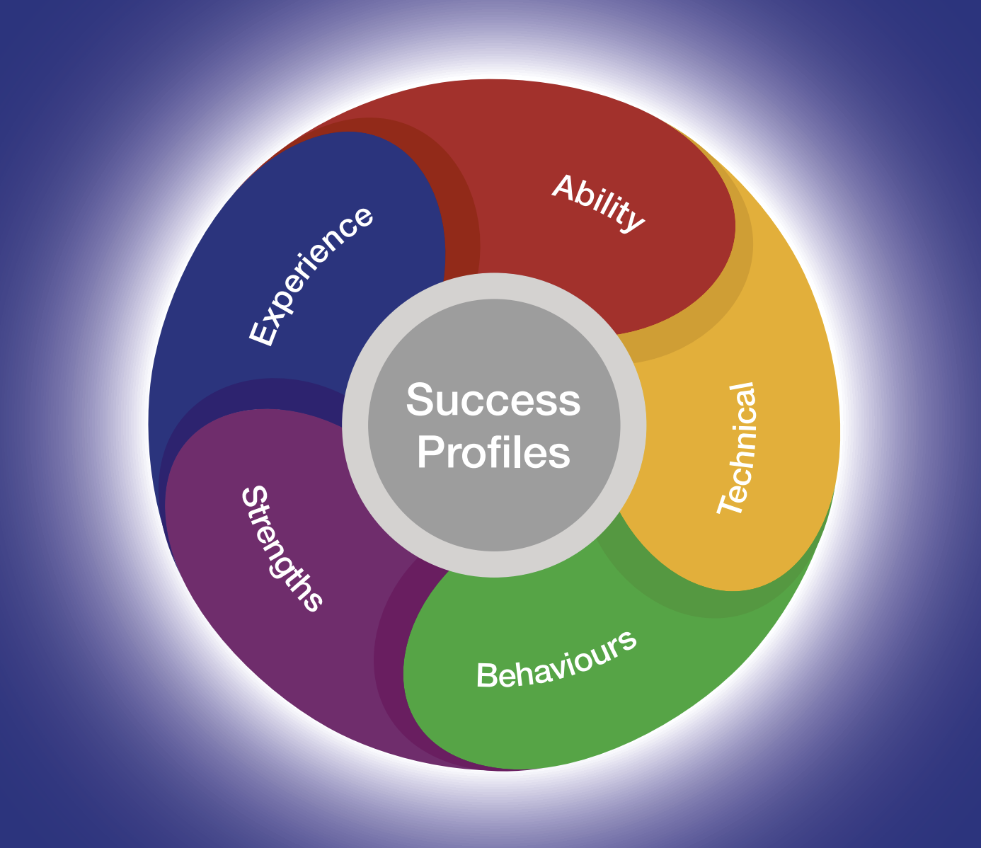

Guidance for writing your Statement and CV

As part of the application process you need to submit a Statement and CV. Both your Statement and CV should demonstrate how you meet the essential experience outlined in the Person Specification section.
Ensure you read through the role information thoroughly and identify the essential criteria for each area. You should ensure you provide evidence for each of the essential experience which are required for the role in your Statement and CV. You may not be progressed to the next stage of the assessment process if you do not provide this evidence.
When structuring your Statements try to:
- Group evidence of the same experience together by using subheadings and paragraphs. This will help to ensure you are writing about the experience that is directly relevant for the role you are applying for.
- You should ensure that you detail recent and relevant examples of the essential experience required for the role and describe the outcome that came from this.
Providing a name-blind CV and Success Profile Statements
In both your CV and Success Profile Statements please remove references to any personal information that could identify you. For example:
- Name and title
- Educational institution names
- Age and gender
- Email address
- Postal address and telephone number
- Nationality and immigration status.
This will help us to recruit based on your knowledge and skills, and not on your background, gender or ethnicity. Recruiting this way is called name-blind recruitment.
For more information on how to write your Statement and CV please visit the Civil Service Careers Website.

Expected Timeline

We will try and offer as much flexibility as we can, but it may not be possible to offer alternative dates for assessments or interviews. You are therefore asked to note the below timetable, exercising flexibility through the recruitment and selection process, in order to meet the dates given. Please note that these dates may be subject to change.

The anticipated timetable is as follows:
Advert Closing Date | 21st June 2026
Outcome of CV and Statement of Suitability | w/c 29th June 2026
Panel Interview and Presentation | w/c 13th July 2026

Working for the Ministry of Justice


Equality, Diversity, Inclusion and Wellbeing
Our departmental values - purpose, humanity, openness and together - are at the heart of our commitment to create a culture where all our people are able to thrive and flourish in the workplace.
We want to attract and retain the best talent from diverse backgrounds and perspectives. We want everyone to be the best of themselves, to feel supported and have a strong sense of belonging in the workplace. Our commitment to creating a diverse and inclusive workforce is reflected in all of our people policies and strategies.
Benefits
As a Ministry of Justice employee, you’ll be entitled to a large range of benefits which include but are not limited to:
Pension
The Civil Service Pension Scheme is one of the best workplace pension schemes in the UK public sector. For SCS 1 roles, you will start with a base salary of £76,000. In addition, through automatic enrolment to the Civil Service Pension Scheme, we will contribute £22,000 to your pension, providing a total reward package of £98,000.
Visit www.civilservicepensionscheme.org.uk for more details.

Generous Annual Leave and Bank Holiday Allowance
25 days annual leave on entry, increasing on a sliding scale to 30 days after 5 years’ service. This is in addition to 8 public holidays. This will be complemented by one further day paid privilege entitlement to mark the King’s Birthday.
Flexible Working
While not every type of flexible working will be suitable for every role and business area, flexible working can take many forms and The Ministry of Justice is committed to delivering its business effectively and sustainably by creating modern and inclusive workplaces that enable smart, flexible and hybrid working.
For more information on our amazing benefits including our Civil Service Pension Scheme, annual and special leave, and our Equality, Diversity, Inclusion and Wellbeing schemes please visit our Senior Civil Service website.

Disability Support

What reasonable adjustments can be made if I have a disability?
We welcome and encourage applications from all candidates and are committed to supporting all candidates to take part in the recruitment process. This includes supporting individuals who have a disability by making reasonable adjustments to the recruitment process.
We are also able to provide support to candidates who require adjustments to the assessment process due to more temporary difficulties (e.g. linked to a recent injury).
We will ask you within your application form if you would like to request reasonable adjustments. If you feel you require any kind of support and/or would like to discuss this with someone, please indicate ‘yes’ to requesting reasonable adjustments and ensure that you respond to the Reasonable Adjustments Scheme team by email.
There are a range of disabilities such as physical, neurological, intellectual or learning difficulties and mental health conditions which may underpin candidates’ requests for reasonable adjustments.
We understand that the support requested will be unique to every candidate and we will work with you to help you to identify your individual requirements.
We make reasonable adjustments so that all candidates are given a fair opportunity to undertake the recruitment process. Therefore, disclosing information regarding your disability or access requirements will have no impact on the outcome of your application, regardless of your request or the role you have applied to.
How we can support you
There are many types of reasonable adjustments that can be made during assessment processes, and the type or combination you choose to request will depend on your individual requirements.
Examples of some types of adjustments include:
- Extra time to complete assessments;
- Providing a break within an assessment;
- Providing interview questions in a written format at the interview as well as orally;
- An interview at a certain time of day;
- Coloured overlays or different fonts for assessment materials.
This is not intended to be an exhaustive list but rather some examples of how we can support you during the SCS Recruitment Process.
Whilst we aim to confirm all adjustments requested, there may be occasions where this isn’t possible. For example, if a candidate were to request that they are not assessed on a specific behaviour outlined in the job advert this would not be possible because the behaviour has been identified as important for the job role and all candidates are assessed against this criterion. If an adjustment cannot be provided, the reasons for this will be explained to you during your contact with the reasonable adjustment scheme team.
Help with your application
During the application process, we will ask you if you require reasonable adjustments. You will need to contact us by email to discuss this with a member of the team. It is important you tell us as early as possible if you would like to request reasonable adjustments so that the recruitment process runs smoothly for you.
If you do decide during the process that you do require adjustments and you have not completed all your assessments, please contact the SCS recruitment team in advance of your next assessment.
If you have any questions in advance of making your application regarding reasonable adjustments for the assessment process, please contact the SCS recruitment team at scsrecruitment@justice.gov.uk.
Do you offer a Disability Confident Scheme for Disabled Persons?
As a Disability Confident employer, the MoJ are able to offer an interview to disabled candidates who meet the minimum selection criteria, except in a limited number of campaigns. This could be in terms of the advertised essential skills and/or application form sift criteria. Within the application form, you will be asked if you would like to be considered for an interview under this scheme, so please make us aware of this when prompted.
FAQs

Can I apply if I am not currently a civil servant?
Yes.
Is this role suitable for part-time working?
This role is available for full-time or flexible working arrangements (including job shares). To discuss your needs in more detail please get in touch with the SCS Recruitment Team.
Where will the role be based?
If successful you will be based in 102 Petty France, London; or 5 Wellington Place, Leeds Relocation costs will not be reimbursed.
The role requires some International travel and if based in Leeds, a significant amount of time travelling to London.
Can I claim back any expenses incurred during the recruitment process?
Unfortunately we will not be able to reimburse you, except in exceptional circumstances.

Am I eligible to apply for this role?
For information on whether you are eligible to apply, please visit Gov.UK.
Is security clearance required?
Yes. If successful you must hold, or be willing to obtain, security clearance to DV level. More information about the vetting process can be found here.
Will this role be overseen by the Civil Service Commission?
No. However, the recruitment process will still be governed by the Civil Service Commission’s Recruitment Principles.
What do I do if I want to make a complaint?
The law requires that selection for appointment to the Civil Service is on merit on the basis of fair and open competition as outlined in the Civil Service Commission’s Recruitment Principles.
Should you feel that the recruitment process has breached the recruitment principles and you wish to make a complaint, you should contact scsrecruitment@justice.gov.uk in the first instance.
If you are not satisfied with the response you receive from the Department you are able to raise a formal complaint in the following order.
- To Shared Service-Connected Ltd (0845 241 5358 (Monday to Friday 08.00 – 18.00) or e-mail Moj-recruitment-vetting-enquiries@gov.sscl.com)
- To Ministry of Justice Resourcing (resourcing-services@justice.gov.uk)
- To the Civil Service Commission (https://civilservicecommission.independent.gov.uk/contact-us/)
What should I do if I think that I have a conflict of interest?
If you believe that you may have a conflict of interest you must declare it by contacting SCS Recruitment on scsrecruitment@justice.gov.uk before submitting your application.

Data Sharing

We will ensure that we will treat all personal information in accordance with data protection legislation, including the General Data Protection Regulation and Data Protection Act 2018.
Data Sharing
To process your application your personal data will be shared with the Ministry of Justice SCS Recruitment Team, campaign Panel Members and anyone else necessary as part of the recruitment process.
The legal basis for processing your personal data is:
Processing is necessary for the performance of a task carried out in the public interest. Personal data are processed in the public interest because understanding civil servant experiences and feelings about working in the Civil Service can inform decision taken to improve these experiences, and ultimately organisation performance.
Sensitive personal data is personal data revealing racial or ethnic origin, political opinions, religious or philosophical beliefs, or trade union membership, and the processing of genetic data, biometric data for the purpose of uniquely identifying a natural person, data concerning health or data concerning a natural person's sex life or sexual orientation.
The legal basis for processing your sensitive personal data is:
- Processing is necessary for reasons of substantial public interest for the exercise of a function of the Crown, a Minister of the Crown, or a government department: it is important to know if groups of staff with specific demographic characteristics have a better or worse experience of working for the Civil Service, so that appropriate action can be taken to level this experience;
- Processing is of a specific category of personal data and it is necessary for the purposes of identifying or keeping under review the existence or absence of equality of opportunity or treatment between groups of people with a view to enabling such equality to be promoted or maintained.
- Please note if you are successful in your application your sensitive personal data will be used as part of the on-boarding process to build your employee record.
For further information please see the GDPR Privacy Notice.
Diversity & Inclusion



The Civil Service is committed to attract, retain and invest in talent where it is found. To learn more, please see the Civil Service People Plan and the Civil Service D&I Strategy

Contact us
Should candidates like to discuss the role in more detail before submitting an application, please contact SCS Recruitment on scsrecruitment@justice.gov.uk.

