Deputy Director, Corporate Operations, Performance & Change
Communications, Private Office, Parliament and Legislation
SCS Pay Band 1
Closing Date: 23:55 31st May 2026

Introduction
The Role
Person
Specification
Benefits
Recruitment
Process
FAQs
Diversity &
Inclusion
Contact Us
Welcome to Communications, Private Office Parliament and Legislation

Thank you for your interest in this exciting role with the CPPL Group

The justice system is an essential public service, relied upon by millions of victims, families and businesses across our country. At the Ministry of Justice (MoJ) we are working to protect and advance the principles of justice and deliver a world-class justice system that works for everyone in society.
Our work spans a wide range of operational, policy and major programme challenges. We protect the public, reduce reoffending, improve access to justice, and continually reform our services.
The Communications, Private Office, Parliament and Legislation Group (CPPL) sits at the heart of the department, supporting Ministers and senior leaders in a fast-paced, high-profile environment. Bringing together communications, ministerial operations, private office and parliamentary business, the Group plays a critical role in enabling delivery of departmental priorities.
The Deputy Director, Corporate Operations, Performance & Change is a pivotal leadership role within CPPL. You will provide the corporate grip that enables the Group to operate as a single, high-performing organisation—leading governance, performance, workforce strategy and organisational capability.
We are looking for a strategic leader who can operate confidently in a complex, ministerially-facing environment. You will be a trusted adviser to senior leaders, bringing together insight, planning and risk management, while driving organisational transformation, including modernising corporate systems and supporting the responsible adoption of AI.
This is a role for someone who can lead through complexity, build strong relationships and deliver at pace, balancing immediate priorities with long-term change.
We particularly encourage applications from candidates from diverse backgrounds. If you want to play a key role at the heart of the Ministry of Justice, we would welcome your application.
Best wishes,
Simon Barrett
Executive Director, Communications, Private Office, Parliament and Legislation

About the Ministry of Justice

The Ministry of Justice is a major government department at the heart of the justice system. We deliver some of the most fundamental public services including courts, tribunals, prisons, legal services, youth justice, probation services, and attendance centres.

The Ministry of Justice (MoJ) works to protect and advance the principles of justice. Our vision is to deliver a world-class justice system that works for everyone in society.
The justice system plays a crucial role in our success as a nation – keeping people safe, emphasising fairness, guaranteeing individual rights and giving businesses confidence to flourish.
The delivery of our three strategic outcomes are central to doing this:
- Punishment that cuts crime: to rebuild confidence in the criminal justice system by protecting the public and reducing reoffending with a sustainable and effective prison and probation service.
- Swifter justice for victims: to rebuild confidence in the criminal justice system by ensuring timely, just outcomes for victims and defendants through a modern and efficient criminal courts system.
- A beacon for justice and the rule of law: to uphold the rule of law at home and abroad; promote our world-leading legal services, which contribute to economic growth; and deliver accessible and timely civil, family and administrative justice.
For more information on who we are and what we do, please visit: https://www.gov.uk/government/organisations/ministry-of-justice.

About the Communications, Private Office, Parliament and Legislation Group

The Communications, Private Office, Parliament and Legislation Group (CPPL) sits at the heart of the Ministry of Justice, supporting Ministers and senior leaders in a fast-paced, high-profile and politically sensitive environment. CPPL brings together functions central to how the department operates, supports Ministers, and engages with Parliament, stakeholders and the public. It ensures departmental priorities are delivered coherently and effectively - aligning policy intent, parliamentary handling, ministerial business and communications into a single, integrated system.

What we do
The Group combines expertise across Communications, Private Office, Parliament and Legislation to provide:

- High-quality ministerial support, with coordinated advice, briefings and private office services.
- Strong parliamentary and legislative grip, including oversight of business, select committee engagement and delivery of the legislative programme.
- Strategic communications leadership, delivering clear, consistent narratives across media, campaigns, internal channels, digital and stakeholders.
- Integrated planning and delivery, aligning policy, parliamentary activity and communications early and progressing them at pace.

Ministers experience this as a single flow, not separate functions. CPPL reflects that reality—improving alignment, reducing disconnects and enabling faster, better-informed decisions.

Working at the centre of the Department
CPPL operates in a demanding environment with high scrutiny, rapid political change and strong public interest. It supports the Deputy Prime Minister, the Lord Chancellor and senior leaders, working closely with No.10, other departments and arm’s-length bodies.
The Group has oversight across the department and plays a key role in assuring ministerial delivery, managing risk and maintaining confidence in the department’s effectiveness at the centre of government.

People, scale and ambition
CPPL spans a large, diverse workforce across communications, ministerial support, parliamentary and legislative functions. As a newly established Group, it operates in a dynamic context with opportunities to further develop its model, capability and culture.
A key focus is ensuring the right systems, governance and leadership are in place to sustain high performance, while continuing to modernise through responsible innovation and new technology.

About the role

Job Title
Deputy Director, Corporate Operations, Performance & Change
Location
National.
Please note the requirements for travel and level of flexibility available as set out in the FAQs section.
Salary
The salary for this role is set within the MoJ SCS PB1 range (£81,000 - £117,800)
External candidates should expect their salary upon appointment to be £81,000 per annum.
Existing Civil Servants will be appointed in line with the Civil Service pay rules in place on the date of their appointment.

Contract Type
This role is being offered on a permanent basis.
This role has a minimum assignment duration of 3 years - in line with the deliverables identified. Please note this is an expectation only, it is not something which is written into your terms and conditions or indeed which the employing organisation or you are bound by.
The Role
The Deputy Director, Corporate Operations, Performance & Change provides strategic leadership for the corporate infrastructure, governance and organisational capability that underpin the Communications, Private Office, Parliament and Legislation Group (CPPL).
Operating across a Group of approximately 370 staff spanning Communications, Ministerial Operations, Private Office, Parliament & Legislation and the Office of the Deputy Prime Minister, the role ensures the systems, governance frameworks and organisational capability required to sustain effective ministerial-facing delivery at the centre of the Ministry of Justice.
The post-holder leads and continuously improves the Group’s corporate operating model, bringing together governance, performance management, business planning, workforce strategy, budgets, risk management and organisational development into a coherent and effective system. The post-holder also oversees the central corporate hub for CPPL, leading the function that provides coordination, insight, control and delivery infrastructure for the Executive Director and senior leaders.
In doing so, the role provides the corporate grip that enables CPPL to operate as a single, high-performing organisation rather than a collection of separate functions.
The role also supports organisational transformation across the Group and modernisation of corporate systems, ensuring the organisation remains resilient and capable of responding to evolving ministerial, parliamentary and departmental demands.
As part of this transformation agenda, the post-holder acts as Senior AI Leader for the Group, providing strategic leadership for the responsible adoption of artificial intelligence and ensuring innovation is balanced with security, ethical and reputational considerations.
As a core member of the CPPL senior leadership team, the Deputy Director acts as a principal strategic adviser to the Executive Director, providing organisational insight, performance challenge and evidence-based advice to support high-quality decision-making and sustained organisational effectiveness.
Key Responsibilities
1. Leadership of Corporate Operations and Organisational Capability
- Design, lead and continuously improve the Group’s corporate operating model, including governance structures, performance management systems, business planning, risk frameworks and organisational capability.
- Lead and develop the Group’s central corporate hub as the focal point for recruitment, governance, planning, performance reporting, finance and workforce coordination, risk oversight and change support across CPPL.
- Provide strategic oversight of Group financial planning and resource allocation, working with Finance and HR partners to ensure workforce structures and operating models remain sustainable.
- Work closely with HR, Finance, Digital, Estates, Commercial, Security and other corporate partners to ensure the Group operates effectively within departmental frameworks while maintaining agility in a fast-paced environment.
- Oversee organisational development, workforce planning, resourcing and talent management across the Group.
- Ensure robust systems for risk management, compliance, information governance, security and business continuity.
2. Transformation, Operating Model Redesign and AI Leadership
- Support organisational transformation across the Group, including operating model reviews and modernisation of corporate systems.
- Act as Senior AI Leader for the Group, providing visible leadership for responsible AI adoption in line with MoJ standards and ethical frameworks.
- Build organisational capability and confidence in the use of AI and digital tools across the Group.
3. Group Integration and Organisational Cohesion
- Support the leadership team with the integration of multiple professional functions into a coherent Group operating model, aligning governance, planning cycles, risk frameworks and ways of working across Communications, Ministerial Operations, Private Office and Parliament & Legislation. Build a strong shared organisational identity across CPPL.
- Lead cross-Group workforce development, leadership engagement and cultural transformation initiatives.
- Support the Executive Director and the leadership team in shaping the Group’s strategic direction and organisational priorities.
4. Strategic Advice and Senior Stakeholder Engagement
- Act as a principal strategic adviser to the Executive Director, providing organisational diagnosis, performance challenge and evidence-based advice on governance, workforce sustainability, operational risk and transformation priorities.
- Support senior leaders to take high-quality decisions through rigorous options analysis, risk assessment and performance insight.
- Negotiate and align corporate priorities with departmental partners including Finance, HR, Digital, Commercial, Security and agencies.
- Represent the Group in departmental committees, cross-government forums and corporate negotiations.
- Provide trusted and confidential advice on complex corporate and operational issues.
5. People, Culture and Leadership
- Provide visible, inclusive and empowering leadership, fostering a collaborative and high-performing culture.
- Lead and develop a multidisciplinary corporate operation and change team, building capability in governance, performance management, transformation and digital innovation.
- Champion diversity, inclusion, wellbeing and staff engagement.
- Develop leaders at every level, strengthening talent pipelines and succession planning.
Person Specification

It is important through the recruitment process that you give evidence and examples of proven experience of each of the essential and desirable criteria.
Later on in the pack you will be told what is being assessed at which stage of the process.

Essential Experience:
- Senior leadership experience in a complex, high-profile or ministerial facing organisation.
- Experience designing and operating corporate systems across complex organisations.
- Experience overseeing corporate operations such as finance, planning, HR, risk and organisational development.
- Experience leading organisational change or transformation programmes.
- Experience providing strategic advice to senior leaders or ministers.
- Experience managing budgets, people and multidisciplinary teams.

Essential Skills/Abilities
- Strong strategic leadership, communication, influencing and negotiation skills.
- Ability to operate with judgement and discretion in politically sensitive environments.
- Exceptional analytical capability.
- Skilled organisational change leader.
- Ability to balance operational delivery with long-term transformation including adoption of AI.
- Strong organisational awareness and risk anticipation capability.
- Ability to build relationships with senior stakeholders across government.
- Commitment to diversity, inclusion and high-performing teams.
Desirable Experience:
- Experience in communications, parliamentary business, private office or ministerial operations.
- Experience sponsoring or leading digital, data or AI-enabled change initiatives.
- Knowledge of the justice system or legal sector.
MoJ SCS Pay Band 1 Behaviours:
You will also be assessed against the following Behaviours during the Recruitment Process:
- Leadership
- Changing and improving
- Communicating and influencing.
- Seeing the bigger picture
Strengths
We are looking to understand what motivates and energises you. We want to see what your natural strengths are and what interests you.
Strengths may be assessed at interview, but these are not shared in advance.
Civil Service Leadership Statement:
All leaders within the Civil Service are expected to demonstrate the qualities within the Civil Service Leadership Statement

Read more in the Civil Service Success Profiles Section.

The Recruitment Process

Recruitment Process
The selection process will be chaired by Simon Barrett, Executive Director of Communications, Private Office Parliament and Legislation. The other panel members will be decided in due course.
Support during the selection process
If you need any support or have any questions during any stage of the selection process, please contact the SCS Recruitment Team scsrecruitment@justice.gov.uk.
Stages of the selection process
Further information
- For those interested in finding out more about the role, we encourage applicants to email CPPLRecruitment@justice.gov.uk
Application
You will need to complete the online application process accessed via the advertisement for this role.
This should be completed no later than 23:55 on 31st May 2026. As part of the application process, you will be asked to complete:
- Responses to the eligibility questions to check you are eligible to apply for the role.
- A response to whether you would like to request reasonable adjustments during the selection process. The Disability Support section explains how adjustments can be made to the selection process to accommodate a disability.
- You will also need to complete a CV and Statement of Suitability. It is important that your CV and Statement of Suitability give evidence and examples of how you meet the essential experience set out on page 11. The Statement of Suitability should be no more than 750 words.
Find out more information about our application process here.
After the Application Stage
You will be advised whether your application has been shortlisted for the next stage of the selection process. If you are shortlisted, we will contact you to arrange the next stage of the selection process.
Unfortunately, due to the anticipated number of applicants for this role, we are unable to provide feedback to those not successful at shortlist stage. Candidates who are shortlisted and attend an interview will be offered verbal feedback from a member of the interview panel.
Other Assessments
Panel Interview and Presentation
You will be invited to attend an interview and presentation with the selection panel. You will be asked to prepare a verbal 5-minute presentation based on a topic that will be provided in advance. The interview and presentation will last for approximately 50 minutes.
What is being assessed?
Behaviours, as listed on page 12.
Strengths
You will be informed at interview which strengths you are being assessed against.
After the Panel Interview
Following the interview, the performance of all candidates will be reviewed, and the successful candidate identified. All candidates will be notified of the outcome as soon as possible after the conclusion of all interviews. If you are not the successful candidate but you meet the standard required, you may be invited to have your details retained on a merit list to be considered for future SCS roles.


Civil Service Behaviours

What are Behaviours?
The Civil Service recruits using Success Profiles and Behaviours are an element of Success Profiles used to see whether candidates are able demonstrate specific Behaviours associated with the role they are applying for during the selection process.
In this process the below Behaviours are most relevant to this role and will be assessed during the interview stage of the process. The definitions of Behaviours are set out below:
Communicating and Influencing
You communicate clearly and with confidence, both verbally and in writing. You are open, honest and transparent in your communications. You communicate effectively with internal and external senior stakeholders to present information in a convincing and influential manner. You tailor your communication methods and content to the audience, simplifying strategic messages.

Leadership
You visibly demonstrate the organisation’s values in all your activity, leading authentically. You seek to engage staff in the aims of the organisation and communicate the organisation’s strategy in an inspiring way. You create an inclusive and fair culture which creates a sense of belonging by treating staff as individuals and actively valuing diversity within the organisation. You empower teams and individuals to excel by creating a shared vision and objectives and demonstrate trust in staff by giving autonomy.
Seeing the Big Picture
You understand the wider context of the organisation’s work, considering the political, social, economic, and technological environment both currently and in the future. You create and implement strategies to achieve the organisation’s aims and meet the needs of the public. You promote the organisation externally, advocating positive outcomes for the sector you operate within. You motivate staff by ensuring they understand how their work fits into the big picture.
Changing and Improving
You create an environment of continuous improvement and change. You see the benefit of change and promote this within your area of responsibility. You identify business needs, both current and future, and use this to identify opportunities for change, utilising innovative solutions that benefit the end user. You are able to embed change, managing risks. You evaluate the impact of change against the expected outcomes for service users and the public.
Please click here or more information on Behaviours and Success Profiles.
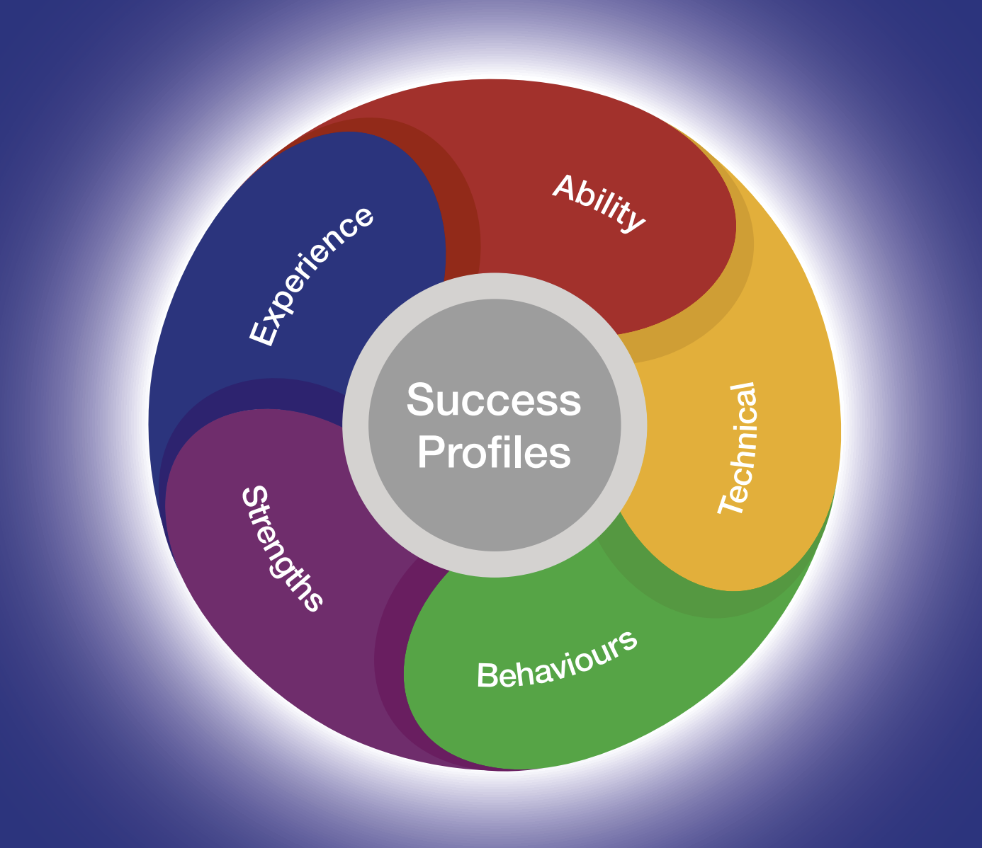

Guidance for writing your Statement and CV

As part of the application process, you need to submit a Statement and CV. Both your Statement and CV should demonstrate how you meet the essential experience outlined in the Person Specification section.
Ensure you read through the role information thoroughly and identify the essential criteria for each area. You should ensure you provide evidence for each of the essential experience which are required for the role in your Statement and CV. You may not be progressed to the next stage of the assessment process if you do not provide this evidence.
When structuring your Statements try to:
- Group evidence of the same experience skills together by using subheadings and paragraphs. This will help to ensure you are writing about the experience that is directly relevant for the role you are applying for.
- You should ensure that you detail recent and relevant examples of the essential experience required for the role and describe the outcome that came from this.

Using AI in your application

Artificial Intelligence can be a useful tool to support your application, however, all examples and statements provided must be truthful, factually accurate and taken directly from your own experience. Where plagiarism has been identified (presenting the ideas and experiences of others, or generated by artificial intelligence, as your own) applications may be withdrawn and internal candidates may be subject to disciplinary action.

Please see our candidate guidance for more information on appropriate and inappropriate use.
Providing a name-blind CV and Success Profile Statements
In both your CV and Success Profile Statements please remove references to any personal information that could identify you. For example:
- Name and title
- Educational institution names
- Age and gender
- Email address
- Postal address and telephone number
- Nationality and immigration status.
This will help us to recruit based on your knowledge and skills, and not on your background, gender or ethnicity. Recruiting this way is called name-blind recruitment.
For more information on how to write your Statement and CV please visit the Civil Service Careers Website

Expected Timeline

We will try and offer as much flexibility as we can, but it may not be possible to offer alternative dates for assessments or interviews. You are therefore asked to note the below timetable, exercising flexibility through the recruitment and selection process, in order to meet the dates given. Please note that these dates may be subject to change.

The anticipated timetable is as follows:
Advert Closing Date | 31st May 2026
Outcome of CV and Statement of Suitability | Week Commencing 8th June 2026
Panel Interview and Presentation | Week Commencing 15th or 22nd June 2026

Working for the Ministry of Justice


Equality, Diversity, Inclusion and Wellbeing
Our departmental values - purpose, humanity, openness and together - are at the heart of our commitment to create a culture where all our people are able to thrive and flourish in the workplace.
We want to attract and retain the best talent from diverse backgrounds and perspectives. We want everyone to be the best of themselves, to feel supported and have a strong sense of belonging in the workplace. Our commitment to creating a diverse and inclusive workforce is reflected in all of our people policies and strategies.
Benefits
As a Ministry of Justice employee, you’ll be entitled to a large range of benefits which include but are not limited to:
Pension
The Civil Service Pension Scheme is one of the best workplace pension schemes in the UK public sector. Visit www.civilservicepensionscheme.org.uk for more details.
Generous Annual Leave and Bank Holiday Allowance
25 days annual leave on entry, increasing on a sliding scale to 30 days after 5 years’ service. This is in addition to 8 public holidays. This will be complemented by one further day paid privilege entitlement to mark the King’s Birthday.
Flexible Working
While not every type of flexible working will be suitable for every role and business area, flexible working can take many forms and The Ministry of Justice is committed to delivering its business effectively and sustainably by creating modern and inclusive workplaces that enable smart, flexible and hybrid working.
For more information on our amazing benefits including our Civil Service Pension Scheme, annual and special leave, and our Equality, Diversity, Inclusion and Wellbeing schemes please visit our Senior Civil Service website.

Disability Support

What reasonable adjustments can be made if I have a disability?
We are committed to supporting all candidates to take part in the recruitment process. This includes supporting individuals who have a disability by making reasonable adjustments to the recruitment process.
If you feel you require any kind of support and/or would like to discuss this with someone, please indicate ‘yes’ to requesting reasonable adjustments in your application form and ensure that you respond to the Reasonable Adjustments Scheme team by email.
How we can support you
There are many types of reasonable adjustments that can be made during assessment processes.
Examples of some types of adjustments include:
- Extra time to complete assessments.
- Providing a break within an assessment.
- Providing interview questions in a written format at the interview as well as orally.
- An interview at a certain time of day.

This is not an exhaustive list but rather some examples of how we can support you during the SCS Recruitment Process.

Whilst we aim to confirm all adjustments requested, there may be occasions where this isn’t possible. If an adjustment cannot be provided, the reasons for this will be explained to you.
Help with your application
It is important you contact us as early as possible by email if you would like to request reasonable adjustments so that the recruitment process runs smoothly for you.
If you do decide during the process that you do require adjustments and you have not completed all your assessments, please contact the SCS recruitment team in advance of your next assessment.
If you have any questions in advance of making your application regarding reasonable adjustments, please contact the SCS recruitment team at scsrecruitment@justice.gov.uk.
Do you offer a Disability Confident Scheme for Disabled Persons?
As a Disability Confident employer, the MoJ offer an interview to disabled candidates who meet the minimum selection criteria, except in a limited number of campaigns. This could be in terms of the advertised essential skills and/or application form sift criteria. Within the application form, you will be asked if you would like to be considered for an interview under this scheme, so please make us aware of this when prompted.
FAQs

Can I apply if I am not currently a civil servant?
Yes.
Is this role suitable for part-time working?
This role is available for full-time or flexible working arrangements (including job shares). To discuss your needs in more detail please get in touch with the SCS Recruitment Team.
Where will the role be based?
If successful you will be based in either 102 Petty France, or one of our regional MoJ offices. Relocation costs will not be reimbursed.
Can I claim back any expenses incurred during the recruitment process?
Unfortunately, we will not be able to reimburse you, except in exceptional circumstances.
Am I eligible to apply for this role?
For information on whether you are eligible to apply, please visit Gov.UK.
Is security clearance required?
Yes. If successful you must hold, or be willing to obtain, security clearance to SC level. More information about the vetting process can be found here.
Will this role be overseen by the Civil Service Commission?
No. However, the recruitment process will still be governed by the Civil Service Commission’s Recruitment Principles.
What do I do if I want to make a complaint?
The law requires that selection for appointment to the Civil Service is on merit on the basis of fair and open competition as outlined in the Civil Service Commission’s Recruitment Principles.
Should you feel that the recruitment process has breached the recruitment principles and you wish to make a complaint, you should contact scsrecruitment@justice.gov.uk in the first instance.
If you are not satisfied with the response you receive from the Department, you are able to raise a formal complaint in the following order.
- To Shared Service-Connected Ltd (0845 241 5358 (Monday to Friday 08.00 – 18.00) or e-mail Moj-recruitment-vetting-enquiries@gov.sscl.com)
- To Ministry of Justice Resourcing (resourcing-services@justice.gov.uk)
- To the Civil Service Commission (https://civilservicecommission.independent.gov.uk/contact-us/)
What should I do if I think that I have a conflict of interest?
If you believe that you may have a conflict of interest you must declare it by contacting SCS Recruitment on scsrecruitment@justice.gov.uk before submitting your application.
Data Sharing

We will ensure that we will treat all personal information in accordance with data protection legislation, including the General Data Protection Regulation and Data Protection Act 2018.
Data Sharing
To process your application your personal data will be shared with the Ministry of Justice SCS Recruitment Team, campaign Panel Members and anyone else necessary as part of the recruitment process.
The legal basis for processing your personal data is:
Processing is necessary for the performance of a task carried out in the public interest. Personal data are processed in the public interest because understanding civil servant experiences and feelings about working in the Civil Service can inform decision taken to improve these experiences, and ultimately organisation performance.
Sensitive personal data is personal data revealing racial or ethnic origin, political opinions, religious or philosophical beliefs, or trade union membership, and the processing of genetic data, biometric data for the purpose of uniquely identifying a natural person, data concerning health or data concerning a natural person's sex life or sexual orientation.
The legal basis for processing your sensitive personal data is:
- Processing is necessary for reasons of substantial public interest for the exercise of a function of the Crown, a Minister of the Crown, or a government department: it is important to know if groups of staff with specific demographic characteristics have a better or worse experience of working for the Civil Service, so that appropriate action can be taken to level this experience;
- Processing is of a specific category of personal data and it is necessary for the purposes of identifying or keeping under review the existence or absence of equality of opportunity or treatment between groups of people with a view to enabling such equality to be promoted or maintained.
- Please note if you are successful in your application your sensitive personal data will be used as part of the on-boarding process to build your employee record.
For further information please see the GDPR Privacy Notice.
Diversity & Inclusion

The Civil Service is committed to attract, retain and invest in talent where it is found. To learn more, please see the Civil Service People Plan and the Civil Service D&I Strategy



Contact us
Should candidates like to discuss the role in more detail before submitting an application, please contact SCS Recruitment on scsrecruitment@justice.gov.uk.

