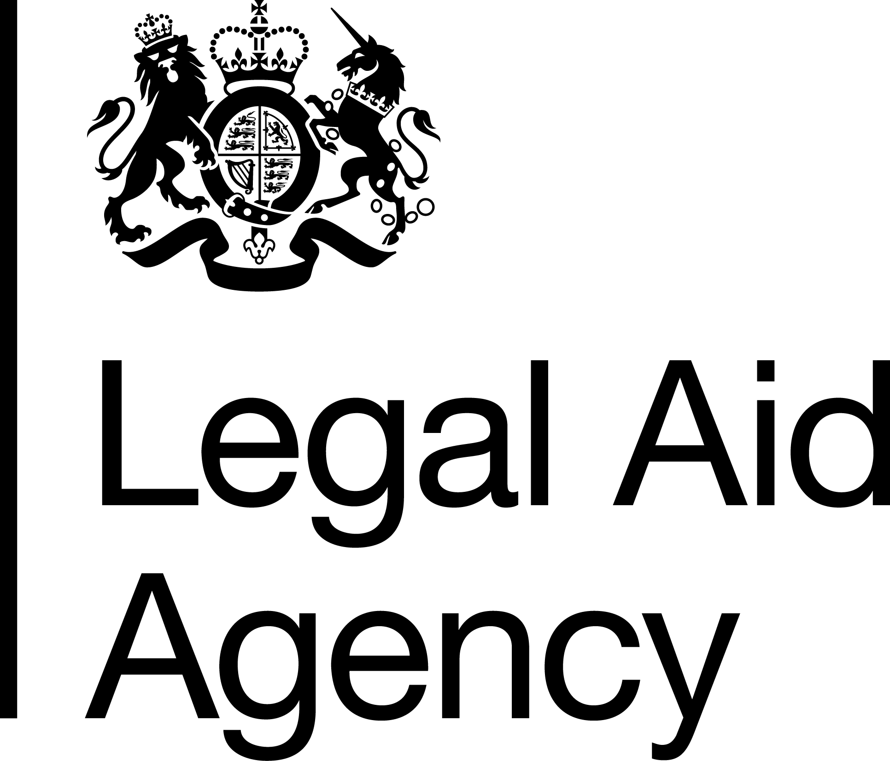

Job Title & Grade: SEO Health & Safety Manager
Contract Type: Permanent
Salary range (depending on location):
National - £42,914-£46,182
London - £49,325-£53,081

Please note that unless you are currently employed by the Civil Service and are earning more than the minimum above, if successful you will be offered the minimum for the grade depending on your location.

Location: National - Any LAA office
Please note that whilst this role is open to all Civil Servants, you can only apply for London, Cambridge and Brighton offices if you are a current LAA staff member based in those offices. This is due to and in line with the LAA's Location Strategy and the Cabinet Office's Places for Growth Strategy.

Minimum Working Pattern:

If you are applying for a part time role, please note that to meet business demands we need cover for a minimum of 29.6 (0.8 full-time equivalent) hours and to cover 4 days of the week

To meet legal requirements, if you are between the ages 16-18 and you are a successful candidate, you will be required to complete an apprenticeship after your initial on the job training.

The Legal Aid Agency
We are an executive agency of the Ministry of Justice (MoJ). We are responsible for operationally administering the legal aid fund to provide criminal and civil legal aid advice to people in England and Wales.
Our people are at the heart of achieving excellence. Employing around 1,200 colleagues across England and Wales, we feel proud to have some of the best People Survey results in the Civil Service.

Corporate Assurance

The role of Health & Safety Manager sits within the Legal Aid Agency’s Corporate Assurance, Risk & Secretariat (CARS) team ultimately reporting to the Head of Assurance.

The CARS team provides advice and assurance on the Agency’s strategic management of risk, information security, physical security, business continuity planning and health & safety.

Job Summary
A specialist professional role providing dedicated support to operational and managerial staff.
A proactive approach is essential, identifying risks and opportunities and suggesting actions and mitigations, achieving compliance with legal requirements while enabling operational delivery.
Building good working relationships is key both within the LAA and across MOJ and other government departments and agencies.
The role of Health & Safety Manager is to lead on all aspects of strategic Health, Safety and Fire and to ensure that all operational and local Health & Safety management arrangements are maintained at the highest standard in line with LAA and MOJ policy. As the Competent Person the role ensures the CEO as the Responsible Person has the support and assurances required by the Health & Safety law.
Our people are primarily working in a hybrid workplace model, and as a business we have fully adopted flexible working practices that allow everyone the opportunity to work from home as well as an office. We also employ contract managers, solicitors and advocates, who routinely work alone and drive as part of their role. Those staff also work in courts, police stations and provider offices as part of their role.
Our offices cover 16 sites in England and Wales, ranging from single occupancy to shared office space alongside other government departments and private companies. Our office in South Tyneside is our largest site which includes a warehouse and Justice Collaboration Centre. That includes a records centre (warehouse) and has sub-tenants from other parts of the MoJ. This site has several H&S challenges including manual handling, working at heights, traffic management and personal safety.
The role includes working closely with GPA and OGD and private sector landlord facilities management teams and LAA Estates lead on facilities management, projects and office moves. Good working relationships with on site LAA staff (Site Leads) are essential to the role.
Key Responsibilities:
Lead policy
- To ensure the Legal Aid Agency (LAA) meets the requirements of Health, Safety and Fire legislation and lead in the delivery of the corporate Health, Safety and Fire delivery plan and policies.
- Develop a strategic delivery plan with recommendations in all aspects of Health & Safety and Fire operational delivery ensuring continuous improvement through engagement.
- To ensure the LAA H&S Policy remains relevant and fit for purpose.

Lead people and develop a culture
- To educate and advise senior leaders and managers on the implementation and delivery of the corporate Health and Safety Policy, procedures and the LAA Health, Safety and Fire Delivery Plan, while utilising the support of Site Leads and a network of regional Health & Safety representatives.
- Develop and maintain relationships across the wider Health, Safety and Fire community (with Central MoJ H&S and Fire Teams, other government departments including GPA and other LAA landlords including both private sector and local authority landlords where appropriate
- Work collaboratively with colleagues in the LAA Estates Team to help ensure the effective management of current sites and to support site moves.
- Work with colleagues in the leadership teams of, security, facilities management, agency partners and communications to support cross MOJ agendas.
- Promote and maintain practices which are free from discrimination, support equality of opportunity and reflect the LAA diversity and equality policy.
- To maximise the use of allocated Health and Safety resource against the Health, Safety and Fire delivery plan
- To line manage the H&S HEO Advisor and ensure personal and team continuous professional development is prioritised.
Manage risk
- To maintain the Health, Safety, and Fire Risk Register.
- Ensure all investigations, audits and training related to all aspects of Health, Safety and Fire are designed and delivered effectively. Identifying gaps and developing solutions to close these gaps.
- To produce and as required present reports on Health Safety and Fire matters to governance committees.
- To ensure the effective running of the LAA National H&S Committee to help fulfil the consultation requirements at a national level regarding health and safety legislation.
- To provide consistent and balanced advice relevant to LAA offices and staff. Promoting a positive health and safety culture.
- Lead projects and team delivery programs within the team, working towards a shared purpose in supporting business continuity, data protection and physical security.
Essential Qualifications
- Minimum qualification: a level 3 occupational safety and health qualification (such as NEBOSH National General Certificate or IOSH Certificate), and
- Currently working towards (if not at this level already) and willing to complete within 2 years of appointment, a level 6 health and safety qualification (such as NEBOSH National Diploma, or equivalent degree). and
- A current member of IOSH at Technical level or above and completing ongoing CPD.
Essential Knowledge, Experience and skills
- Experience in fire safety, water hygiene and asbestos risk management.
- Ability to efficiently plan, organise time and workload to ensure delivery of plans.
- Ability to communicate effectively, interacting with and engaging colleagues at all levels – beyond your own team - to achieve shared goals.
- Ability to work autonomously, identify and mitigate risks and spot opportunities to improve the health, safety and wellbeing of staff.
- Knowledge and understanding of health, safety, wellbeing and stress strategies, to provide competent and trusted advice.
- Ability to write engaging copy with some experience of writing for impact e.g. policy, procedures and risk assessments.
- Knowledge and/or experience of how to use quantitative and qualitative data to inform future plans, including ISO standards in H&S.
- Experience of facilitation of workshops, design and delivery of training and planning and delivering events.
Desirable Knowledge, Experience and skills
- Working towards Chartered IOSH status.
- Experience of working with a variety of remote working tools.
- An understanding of the criminal justice system.
- Familiarity with using MS Co-pilot or similar tools.
Person Specification

This role requires National Security Vetting Level CTC

You’ll have experience of applying Health, Safety and Fire legislation to a range of organisational processes and in a variety of settings.

You’ll work well with people and be able to maintain positive relationships whilst ensuring legislative obligations are met, communicating effectively at all levels.

You’ll enjoy working in a self-motivated way balancing pro-active and re-active work. You will be able to reprioritise effectively during busy periods, efficiently planning and organising your time and workload to ensure the delivery of various workstreams simultaneously.

Ability to interact with and engage colleagues – beyond your own team - to achieve shared goals.

Ability to work autonomously, identify and mitigate risks and spot opportunities to improve the health and safety of staff.

The role includes travelling to inspect and deliver support to all 16 LAA offices with occasional overnight stays dependent on base location.

Assessment approach

Application Process
To apply please submit a CV and statement of suitability showing how you meet the essential criteria in no more than 1000 words.
Your statement should demonstrate your ability to do all the essential criteria listed, using examples can help strengthen your application.
Please note that we only require a CV and Statement of Suitability for your application. The wording on this advert may suggest that an Experience question is also required, however this is not necessary.

Interview / assessment Process

If you are successful through the application stage, you will be invited to an interview / assessment centre in person or via Microsoft Teams where you will be assessed against the following:

- Strengths relevant to the role

- The following Behaviours:

  - Communicating and Influencing
  - Changing and Improving
  - Working together
  - Delivering at Pace
  - Making Effective Decisions

Your Experience of implementing, promoting, or understanding diversity and inclusion policy - Diversity is the presence of difference, this can include one or more of the protected characteristics (Gender, Age, Race, Disability etc.) or it can be about working patterns, whether we like to jump into a task or reflect on it before acting. Inclusion is how we welcome, value, and celebrate diversity, giving everyone a voice, tapping into ideas, and enabling everyone to be themselves at work and achieve their potential.

For this grade/ role we would expect the candidate to demonstrate understanding of the terms Diversity and Inclusion and be able to explain why they are important in a work environment. We would also expect examples of action they have taken to embrace diversity (e.g., increasing understanding for self or others) or improve inclusion at a team or wider group level.

Practical Exercise

You will also be asked to review and prioritise a small number of H&S issues and then lead the panel through your decisions and the reasoning behind them.

You will be given the information you need during the interview slot and there is no need to prepare. Your talk through / presentation should take no more than 20 minutes after which, the panel may ask you questions on the exercise.

Shortlisting is planned for week commencing Monday 18th May 2026
Interviews are planned for week commencing Monday 1st June 2026
If you would like more information on this opportunity, please contact – Lorraine Fellows – Lorraine.Fellows2@justice.gov.uk (current post holder) or Gary Winter – Gary.Winter@justice.gov.uk (Head of Governance).

Our LAA commitment to Diversity and Inclusion
The Civil Service is committed to attract, retain, and invest in talent wherever it is found. To learn more please see the Civil Service People Plan and the Civil Service Diversity and Inclusion Strategy.
As a Disability Confident organisation, we will offer a guaranteed interview to candidates with a disability who meet the essential criteria for this role. Under the Equality Act 2010 a disability is defined as a physical or mental impairment which has a substantial and long-term adverse effect on your ability to carry out normal day-to-day activities which has lasted, or is expected to last, at least 12 months.
If you are responding to a role within the Legal Aid Agency and would like to be considered under the guaranteed interview, please indicate this in your application and let us know of any reasonable adjustments you may require during the sift or later selection processes.
The LAA’s goal is to build an organisation that is open and inclusive and truly values and celebrates the diversity of its workforce. One that reflects and understands the needs of the diverse society we serve. This is regardless of social background, gender, age, ethnicity, sexual orientation, beliefs, disabilities or long-term illness or caring responsibilities.
Reasonable Adjustments
We are committed to ensuring our recruitment process is inclusive and accessible to all. If you have a disability or long-term condition (for example dyslexia, anxiety, autism, a mobility condition or hearing loss) and need us to make any reasonable adjustments to support you through the recruitment process, please let us know by adding the information to the applications system or emailing LAARecruitment@justice.gov.uk after you have applied so that we can discuss options with you.


Complaints procedure
If you have any complaints about this recruitment activity, please share your concerns by emailing LAARecruitment@justice.gov.uk initially. We aim to respond to any complaint within 10 working days.

